Name : Junaid Altaf Girkar

SAP ID : 60004190057

Year : Third Year

**Semester : VI**

Branch : Computer Engineering

Course Name : Big Data Infrastructure

**Course Code : DJ19CEEC6011**

INDEX

| **Experiment Number** | **Experiment Aim** | **Page Number** |
| --- | --- | --- |
| 1 | Installation of Hadoop on a single node cluster | 3 |
| 2 | Execution OF HDFS Commands | 8 |
| 3 | Execution of MapReduce program for counting word occurrences in a text file | 18 |
| 4 | Execute HIVE commands to load, insert, retrieve, update, or delete data in the tables. | 21 |
| 5 | Execute HBASE commands to perform basic CRUD operations and joins | 34 |
| 6 | Execute PIG built in commands and run pig scripts on HDFS | 44 |
| 7 | Write a program to create rdd, perform various operations and find occurrences of each word. | 57 |
| 8 | Execute any two ML algorithms using Apache Spark Mlib and compare its accuracy | 66 |
| 9 | Perform CRUD Operations using Mongodb | 76 |
| 10 | Read streaming data using Kafka. | 88 |
| 11 | Case study to perform Sentiment analysis using Spark Streaming | 95 |

EXPERIMENT - 1

**AIM**: Installation of Hadoop on a single node cluster.

**THEORY**:

# **What is Hadoop**

Hadoop is an open source framework from Apache and is used to store process and analyse data which are very huge in volume. Hadoop is written in Java and is not OLAP (online analytical processing). It is used for batch/offline processing.It is being used by Facebook, Yahoo, Google, Twitter, LinkedIn and many more. Moreover it can be scaled up just by adding nodes in the cluster.

## **Modules of Hadoop**

* **HDFS:** Hadoop Distributed File System. Google published its paper GFS and on the basis of that HDFS was developed. It states that the files will be broken into blocks and stored in nodes over the distributed architecture.
* **Yarn:** Yet another Resource Negotiator is used for job scheduling and manage the cluster.
* **Map Reduce:** This is a framework which helps Java programs to do the parallel computation on data using key value pair. The Map task takes input data and converts it into a data set which can be computed in Key value pair. The output of Map task is consumed by reduce task and then the out of reducer gives the desired result.
* **Hadoop Common:** These Java libraries are used to start Hadoop and are used by other Hadoop modules.

## **Hadoop Architecture**

The Hadoop architecture is a package of the file system, MapReduce engine and the HDFS (Hadoop Distributed File System). The MapReduce engine can be MapReduce/MR1 or YARN/MR2.

A Hadoop cluster consists of a single master and multiple slave nodes. The master node includes Job Tracker, Task Tracker, NameNode, and DataNode whereas the slave node includes DataNode and TaskTracker.

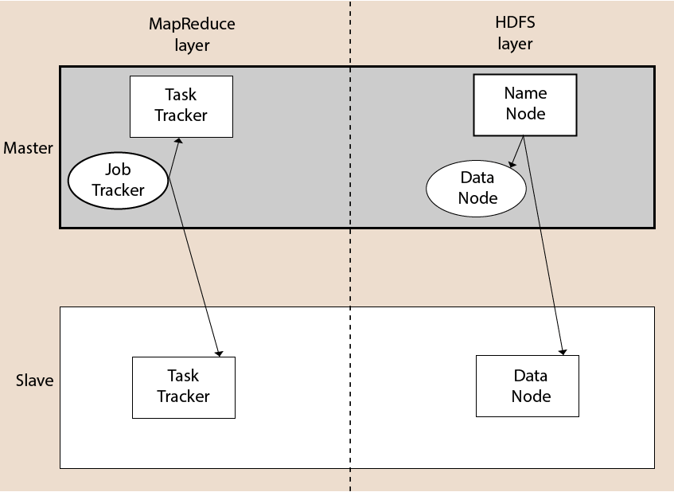

## **Hadoop Distributed File System**

The Hadoop Distributed File System (HDFS) is a distributed file system for Hadoop. It contains a master/slave architecture. This architecture consist of a single NameNode performs the role of master, and multiple DataNodes performs the role of a slave.

Both NameNode and DataNode are capable enough to run on commodity machines. The Java language is used to develop HDFS. So any machine that supports Java language can easily run the NameNode and DataNode software.

### **NameNode**

* It is a single master server exist in the HDFS cluster.
* As it is a single node, it may become the reason of single point failure.
* It manages the file system namespace by executing an operation like the opening, renaming and closing the files.
* It simplifies the architecture of the system.

### **DataNode**

* The HDFS cluster contains multiple DataNodes.
* Each DataNode contains multiple data blocks.
* These data blocks are used to store data.
* It is the responsibility of DataNode to read and write requests from the file system's clients.
* It performs block creation, deletion, and replication upon instruction from the NameNode.

### **Job Tracker**

* The role of Job Tracker is to accept the MapReduce jobs from client and process the data by using NameNode.
* In response, NameNode provides metadata to Job Tracker.

### **Task Tracker**

* It works as a slave node for Job Tracker.
* It receives task and code from Job Tracker and applies that code on the file. This process can also be called as a Mapper.

## **MapReduce Layer**

The MapReduce comes into existence when the client application submits the MapReduce job to Job Tracker. In response, the Job Tracker sends the request to the appropriate Task Trackers. Sometimes, the TaskTracker fails or time out. In such a case, that part of the job is rescheduled.

## **Advantages of Hadoop**

* **Fast:** In HDFS the data distributed over the cluster and are mapped which helps in faster retrieval. Even the tools to process the data are often on the same servers, thus reducing the processing time. It is able to process terabytes of data in minutes and Peta bytes in hours.
* **Scalable:** Hadoop cluster can be extended by just adding nodes in the cluster.
* **Cost Effective:** Hadoop is open source and uses commodity hardware to store data so it really cost effective as compared to traditional relational database management system.
* **Resilient to failure:** HDFS has the property with which it can replicate data over the network, so if one node is down or some other network failure happens, then Hadoop takes the other copy of data and use it. Normally, data are replicated thrice but the replication factor is configurable.

**IMPLEMENTATION**:

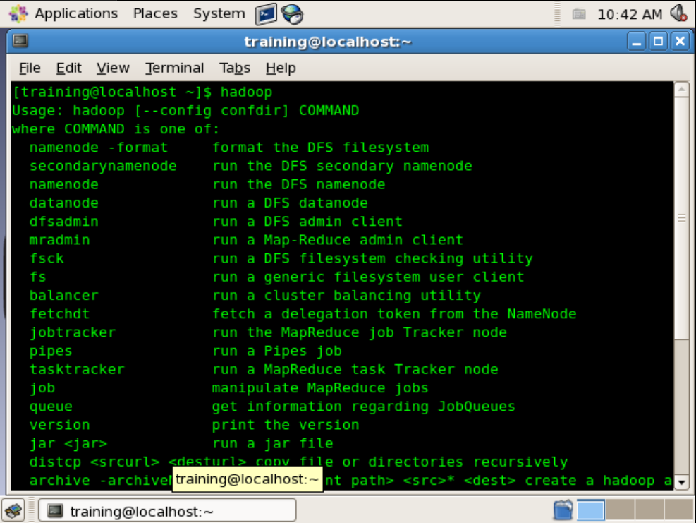

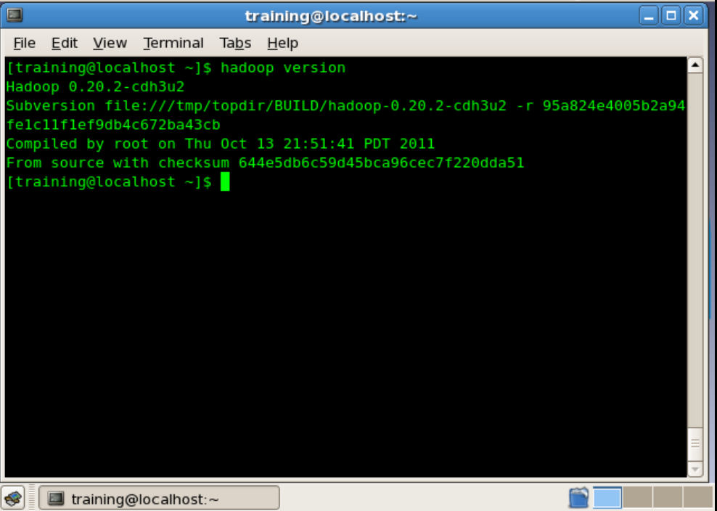

**CONCLUSION**: We learnt about big data tools like Hadoop and implemented it in cloudera.

EXPERIMENT - 2

**AIM**: Execution of HDFS commands

**THEORY**:

### **What is DFS?**

DFS stands for the distributed file system, it is a concept of storing the file in multiple nodes in a distributed manner. DFS actually provides the Abstraction for a single large system whose storage is equal to the sum of storage of other nodes in a cluster.

HDFS(Hadoop Distributed File System) is utilised for storage permission as a Hadoop cluster. It is mainly designed for working on commodity Hardware devices(devices that are inexpensive), working on a distributed file system design. HDFS is designed in such a way that it believes more in storing the data in a large chunk of blocks rather than storing small data blocks. HDFS in Hadoop provides Fault-tolerance and High availability to the storage layer and the other devices present in that Hadoop cluster.

HDFS is capable of handling larger size data with high volume velocity and variety makes Hadoop work more efficient and reliable with easy access to all its components. HDFS stores the data in the form of the block where the size of each data block is 128MB in size which is configurable means you can change it according to your requirement in the hdfs-site.xml file in your Hadoop directory.

### Some Important Features of HDFS(Hadoop Distributed File System)

* It’s easy to access the files stored in HDFS.
* HDFS also provides high availability and fault tolerance.
* Provides scalability to scaleup or scaledown nodes as per our requirement.
* Data is stored in a distributed manner i.e. various Datanodes are responsible for storing the data.
* HDFS provides Replication because of which there is no fear of Data Loss.
* HDFS Provides High Reliability as it can store data in a large range of Petabytes.
* HDFS has in-built servers in Name node and Data Node that helps them to easily retrieve the cluster information.
* Provides high throughput.

### HDFS Storage Daemon’s

As we all know Hadoop works on the MapReduce algorithm which is a master-slave architecture, HDFS has NameNode and DataNode that works in the similar pattern.

**1. NameNode**: NameNode works as a Master in a Hadoop cluster that Guides the Datanode(Slaves). Namenode is mainly used for storing the Metadata i.e. nothing but the data about the data. Meta Data can be the transaction logs that keep track of the user’s activity in a Hadoop cluster.

Meta Data can also be the name of the file, size, and the information about the location(Block number, Block ids) of Datanode that Namenode stores to find the closest DataNode for Faster Communication. Namenode instructs the DataNodes with the operation like delete, create, Replicate, etc.

As our NameNode is working as a Master it should have a high RAM or Processing power in order to Maintain or Guide all the slaves in a Hadoop cluster. Namenode receives heartbeat signals and block reports from all the slaves i.e. DataNodes.

**2.** **DataNode**: DataNodes works as a Slave DataNodes are mainly utilized for storing the data in a Hadoop cluster, the number of DataNodes can be from 1 to 500 or even more than that, the more number of DataNode your Hadoop cluster has More Data can be stored. so it is advised that the DataNode should have High storing capacity to store a large number of file blocks. Datanode performs operations like creation, deletion, etc. according to the instruction provided by the NameNode.

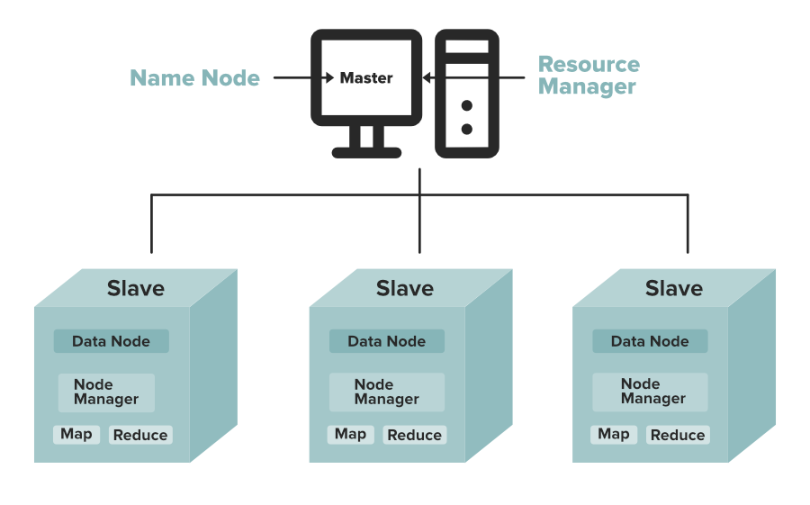

**IMPLEMENTATION**:

| [training@localhost ~]$ pwd |
| --- |

| /home/training |
| --- |

| [training@localhost ~]$ ls |
| --- |

| 201212daily.txt KMeans$Map.class sample5.txt aaa.txt KMeans$Reduce.class sample6.txt abcde km.jar sample-bloomfilter a.txt Kpack1 .java sample-filter backgrounds Kpack1.java sorrt.jar bb.txt Kpack1.java~ sortData BloomFilter.java kriti sortData~ bloom.jar lib SortData book ma SortData.class bookinfo ma.jar SortData.java bookinfo~ mat sorting Books mat1 sorting1.jar b.txt mat1.jar sort.jar build mat2.jar SortMapper Centroid mat3.jar SortMapper.class Centroid~ mat4.jar SortMapper.java centroids.txt mat5.jar SortReducer centroid.txt mat6.jar SortReducer.class Clustering1.java mat.jar SortReducer.java Clustering1.java~ mat.jar-C stored cust_file_class_2009 matrcies1.jar stored~ Data matrices student1.java data1_2009 matrices1.jar student.java data1_2009~ matrix t data2_2009 Matrix.class table1.txt data2_2009~ matrix.jar table1.txt~ data3_2009~ matrix.java table2.txt data4_2009~ #Matrix.java# table2.txt~ data.txt Matrix.java temp data.txt~ Matrix.java~ Templates deptinfo Matrix$Map.class TempStatsStore derby.log matrixmuln test Desktop Matrixmulti test1.txt dir6 Matrixmulti.java test1.txt~ dirbook Matrixmulti.java~ test.jar djs Matrix$Reduce.class textfile2.txt djs.jar Matrix.txt textfile3 djss matrixx.jar textfile4 eclipse matt textfile.txt emp mattt training_materials emp~ MRDemo.jar tushar emp2 new file tushar1 emp2~ new file~ tushar1.jar emp2.java new file 1 tushar.jar emp3.java new file 2 untitled folder emp.java new file 2~ w emp_name order_custid WeatherData example~ pig_1443861414011.log w.jar file1.txt pig_1443947154908.log word file1.txt~ pig_1443949486150.log Word1.java filetext4 pig_1444470259655.log word2.jar FilterJob.java pig_1444547817901.log WordCount12.java FilterMapper.java pig_1448259294240.log wordcount1.jar gender pig_1448278570362.log WordCount.class hadoop pig_1448684754725.log wordcount_classes HadoopPoem1.txt pig_1448685352126.log wordcount.java HadoopPoem2.txt poem912 WordCount.java inner2.txt posts.txt WordCount.java~ inner.txt product_file_class_2009 WordCount.java~~ input proto_file1.txt WordCount$MapClass.class java proto_file2.txt WordCount$Reduce.class kmeans proto_file3.txt word.jar kmeans1.jar proto_file4.txt wordtext KMeans.class qqq workspace kmeans.jar QueryResult.java w.txt "KMeans.java" sample w.txt~ "KMeans.java"~ sample~ www.java KMeans.java sample1 wwww.jar KMeans.java~ sample1~ |
| --- |

| [training@localhost ~]$ hadoop dfs -ls |
| --- |

| Found 109 items -rw-r--r-- 1 training supergroup 1390 2015-10-02 20:20 /user/training/Books drwxr-xr-x - training supergroup 0 2014-08-17 03:50 /user/training/WeatherData -rw-r--r-- 1 training supergroup 3103 2016-02-16 21:54 /user/training/WordCount.java drwxr-xr-x - training supergroup 0 2015-10-17 02:34 /user/training/_sqoop -rw-r--r-- 1 training supergroup 0 2018-02-01 23:46 /user/training/aaa.txt drwxr-xr-x - training supergroup 0 2018-02-02 00:45 /user/training/abcdef -rw-r--r-- 1 training supergroup 12 2020-09-25 00:58 /user/training/asd -rw-r--r-- 1 training supergroup 18 2018-02-01 23:52 /user/training/bb.txt drwxr-xr-x - training supergroup 0 2016-03-09 22:55 /user/training/bbb11451728037137 drwxr-xr-x - training supergroup 0 2016-03-10 01:05 /user/training/bbbb17422138347695 drwxr-xr-x - training supergroup 0 2016-03-10 01:06 /user/training/bbbb17569614160750 drwxr-xr-x - training supergroup 0 2016-03-10 01:15 /user/training/bbbb18073723471225 -rw-r--r-- 1 training supergroup 2944 2015-09-26 02:37 /user/training/bookinfo drwxr-xr-x - training supergroup 0 2015-09-20 01:38 /user/training/class2009_dir1 -rw-r--r-- 1 training supergroup 81 2015-09-18 21:05 /user/training/deptinfo drwxr-xr-x - training supergroup 0 2014-08-17 01:59 /user/training/dir1 drwxr-xr-x - training supergroup 0 2015-09-12 02:42 /user/training/dir10 drwxr-xr-x - training supergroup 0 2015-09-19 02:00 /user/training/dir100 drwxr-xr-x - training supergroup 0 2015-09-19 02:42 /user/training/dir1000 drwxr-xr-x - training supergroup 0 2014-08-22 02:30 /user/training/dir11 drwxr-xr-x - training supergroup 0 2014-08-22 02:35 /user/training/dir12 drwxr-xr-x - training supergroup 0 2014-08-17 01:59 /user/training/dir2 drwxr-xr-x - training supergroup 0 2014-08-17 01:59 /user/training/dir3 drwxr-xr-x - training supergroup 0 2014-08-17 01:59 /user/training/dir4 drwxr-xr-x - training supergroup 0 2014-08-17 01:59 /user/training/dir5 drwxr-xr-x - training supergroup 0 2014-08-17 03:03 /user/training/dir6 drwxr-xr-x - training supergroup 0 2014-08-17 03:04 /user/training/dir7 drwxr-xr-x - training supergroup 0 2014-08-17 04:22 /user/training/dir9 -rw-r--r-- 1 training supergroup 1390 2015-10-02 20:22 /user/training/dirbook drwxr-xr-x - training supergroup 0 2021-10-05 01:06 /user/training/djsin drwxr-xr-x - training supergroup 0 2021-10-05 01:06 /user/training/djsout drwxr-xr-x - training supergroup 0 2021-10-05 01:16 /user/training/djsout1 drwxr-xr-x - training supergroup 0 2021-10-05 01:12 /user/training/djss drwxr-xr-x - training supergroup 0 2015-10-17 02:14 /user/training/emp drwxr-xr-x - training supergroup 0 2015-10-17 02:34 /user/training/emp2 drwxr-xr-x - training supergroup 0 2015-10-10 23:18 /user/training/emp_dir drwxr-xr-x - training supergroup 0 2015-10-17 02:26 /user/training/employee drwxr-xr-x - training supergroup 0 2015-10-17 23:39 /user/training/employee2 drwxr-xr-x - training supergroup 0 2015-10-17 23:42 /user/training/employee3 drwxr-xr-x - training supergroup 0 2015-11-27 20:53 /user/training/hadoop drwxr-xr-x - training supergroup 0 2021-07-30 02:17 /user/training/hadoopinword drwxr-xr-x - training supergroup 0 2021-07-30 02:12 /user/training/hadoopword drwxr-xr-x - training supergroup 0 2021-07-30 02:21 /user/training/hadoopword1 drwxr-xr-x - training supergroup 0 2016-02-16 02:30 /user/training/imput1234 -rw-r--r-- 1 root supergroup 13 2017-03-10 23:22 /user/training/inword -rw-r--r-- 1 training supergroup 69 2015-10-10 02:35 /user/training/join -rw-r--r-- 1 training supergroup 105 2015-10-10 02:38 /user/training/join2 drwxr-xr-x - training supergroup 0 2016-03-09 22:47 /user/training/kmeansinput drwxr-xr-x - training supergroup 0 2016-03-09 22:42 /user/training/kmeansoutput drwxr-xr-x - training supergroup 0 2016-03-09 22:48 /user/training/kmeansoutput10970575692823 drwxr-xr-x - training supergroup 0 2016-03-08 22:12 /user/training/kminput drwxr-xr-x - training supergroup 0 2016-03-08 22:13 /user/training/kmoutput -rw-r--r-- 1 root supergroup 235 2017-03-10 23:44 /user/training/ma drwxr-xr-x - training supergroup 0 2021-10-12 00:14 /user/training/mat1in drwxr-xr-x - training supergroup 0 2021-10-12 00:12 /user/training/mat1out drwxr-xr-x - training supergroup 0 2021-10-12 00:41 /user/training/mat1out1 drwxr-xr-x - training supergroup 0 2021-10-13 02:35 /user/training/matricesin drwxr-xr-x - training supergroup 0 2021-10-13 02:33 /user/training/matricesout drwxr-xr-x - training supergroup 0 2021-10-13 02:37 /user/training/matricesout1 drwxr-xr-x - training supergroup 0 2016-02-23 00:16 /user/training/matrixinput drwxr-xr-x - training supergroup 0 2016-02-23 00:17 /user/training/matrixoutput drwxr-xr-x - training supergroup 0 2021-10-12 01:09 /user/training/mattin drwxr-xr-x - training supergroup 0 2021-10-12 01:05 /user/training/mattout drwxr-xr-x - training supergroup 0 2021-10-12 01:11 /user/training/mattout1 drwxr-xr-x - training supergroup 0 2021-10-12 01:21 /user/training/matttin drwxr-xr-x - training supergroup 0 2021-10-12 01:20 /user/training/matttout drwxr-xr-x - training supergroup 0 2021-10-12 01:22 /user/training/matttout1 -rw-r--r-- 1 training supergroup 235 2017-03-17 01:44 /user/training/mm drwxr-xr-x - training supergroup 0 2020-09-25 02:00 /user/training/out1 drwxr-xr-x - training supergroup 0 2021-10-13 03:18 /user/training/out25 drwxr-xr-x - training supergroup 0 2016-02-16 02:32 /user/training/output1234 drwxr-xr-x - training supergroup 0 2017-03-10 23:27 /user/training/oword2 -rw-r--r-- 1 training supergroup 16 2015-10-04 01:23 /user/training/pig -rw-r--r-- 1 training supergroup 32 2015-10-04 02:04 /user/training/pig1 -rw-r--r-- 1 training supergroup 90 2015-11-23 03:12 /user/training/poem -rw-r--r-- 1 training supergroup 90 2015-09-12 02:41 /user/training/poem912 drwxr-xr-x - training supergroup 0 2021-10-13 03:02 /user/training/sortingin drwxr-xr-x - training supergroup 0 2021-10-13 03:00 /user/training/sortingout drwxr-xr-x - training supergroup 0 2021-10-13 03:05 /user/training/sortingout1 drwxr-xr-x - training supergroup 0 2021-10-13 03:08 /user/training/sortingout2 drwxr-xr-x - training supergroup 0 2021-10-13 03:12 /user/training/sortingout5 drwxr-xr-x - training supergroup 0 2016-02-22 22:34 /user/training/sortinput drwxr-xr-x - training supergroup 0 2021-10-13 03:17 /user/training/sortinputf drwxr-xr-x - training supergroup 0 2021-08-28 00:36 /user/training/sortout drwxr-xr-x - training supergroup 0 2016-02-22 22:34 /user/training/sortoutput drwxr-xr-x - training supergroup 0 2016-02-22 22:35 /user/training/sortoutput2 drwxr-xr-x - training supergroup 0 2017-03-03 21:50 /user/training/sortoutputtt drwxr-xr-x - training supergroup 0 2021-08-28 01:04 /user/training/ss1 drwxr-xr-x - training supergroup 0 2021-08-28 01:03 /user/training/sss drwxr-xr-x - training supergroup 0 2015-10-10 03:53 /user/training/str drwxr-xr-x - training supergroup 0 2015-10-17 01:26 /user/training/stud drwxr-xr-x - training supergroup 0 2015-10-17 01:42 /user/training/stud1 drwxr-xr-x - training supergroup 0 2015-10-17 01:43 /user/training/stud2 drwxr-xr-x - training supergroup 0 2015-10-17 02:01 /user/training/student -rw-r--r-- 1 training supergroup 86 2015-10-10 03:40 /user/training/table2 drwxr-xr-x - training supergroup 0 2016-02-05 19:51 /user/training/test drwxr-xr-x - training supergroup 0 2021-10-05 01:48 /user/training/test1 -rw-r--r-- 1 training supergroup 29 2021-10-05 01:54 /user/training/test2 drwxr-xr-x - training supergroup 0 2021-10-05 01:51 /user/training/testout -rw-r--r-- 1 training supergroup 24 2016-02-12 00:40 /user/training/textfile.txt drwxr-xr-x - training supergroup 0 2020-11-07 00:08 /user/training/tushar1input drwxr-xr-x - training supergroup 0 2020-11-07 00:13 /user/training/tushar1output drwxr-xr-x - training supergroup 0 2020-11-07 00:24 /user/training/tushar1output9 drwxr-xr-x - training supergroup 0 2020-11-06 22:17 /user/training/tusharinput drwxr-xr-x - training supergroup 0 2020-11-06 22:12 /user/training/tusharoutput drwxr-xr-x - training supergroup 0 2020-11-06 22:14 /user/training/tusharoutput1 drwxr-xr-x - training supergroup 0 2020-11-06 22:17 /user/training/tusharoutput2 drwxr-xr-x - training supergroup 0 2015-09-12 02:33 /user/training/user -rw-r--r-- 1 training supergroup 59 2015-10-10 00:56 /user/training/wordcount |
| --- |

| [training@localhost ~]$ hadoop dfs -mkdir hadoop [training@localhost ~]$ hadoop dfs -cp /user/training/WordCount.java /user/training/hadoop [training@localhost ~]$ hadoop dfs -touchz rem.txt [training@localhost ~]$ hadoop dfs -mv /user/training/rem.txt /user/training/hadoop [training@localhost ~]$ hadoop dfs -mkdir hadoop2 [training@localhost ~]$ hadoop dfs -cp /user/training/hadoop/rem.text /user/training/hadoop2 |
| --- |

| cp: File does not exist: /user/training/hadoop/rem.text |
| --- |

| [training@localhost ~]$ hadoop dfs -cp /user/training/hadoop/rem.txt /user/training/hadoop2 [training@localhost ~]$ hadoop dfs -rm  [training@localhost ~]$ hadoop dfs -rm /user/training/hadoop2/rem.txt |
| --- |

| Deleted hdfs://localhost/user/training/hadoop2/rem.txt |
| --- |

| [training@localhost ~]$ hadoop dfs -rm -rf /user/training/hadoop2 |
| --- |

| rm: cannot remove -rf: No such file or directory. rm: Cannot remove directory "hdfs://localhost/user/training/hadoop2", use -rmr instead |
| --- |

| [training@localhost ~]$ hadoop dfs -rmr /user/training/hadoop2 |
| --- |

| Deleted hdfs://localhost/user/training/hadoop2 |
| --- |

| [training@localhost ~]$ hadoop dfs -cat /user/training/bb.txt |
| --- |

| jhhhl kjhkjh laks |
| --- |

[training@localhost ~]$ hadoop dfs -cp /user/training/WordCount.java

/user/training/hadoop

[training@localhost ~]$ hadoop dfs -mv /user/training/WordCount.java

| /user/training/hadoop mv: Failed to rename hdfs://localhost/user/training/WordCount.java to /user/training/hadoop |
| --- |

[training@localhost ~]$ hadoop dfs -copyFromLocal /home/training/aaa.txt /user/training/hadoop

| [training@localhost ~]$ hadoop dfs -copyToLocal /user/training/hadoop/WordCount.java /home/training |
| --- |

| copyToLocal: Target /home/training/WordCount.java already exists |
| --- |

| [training@localhost ~]$ hadoop dfs -moveToLocal /user/training/hadoop/WordCount.java /home/training |
| --- |

| Option '-moveToLocal' is not implemented yet. |
| --- |

| [training@localhost ~]$ hadoop dfs -moveFromLocal /user/training/hadoop/WordCount.java /home/training |
| --- |

moveFromLocal: File /user/training/hadoop/WordCount.java does not exist.

| [training@localhost ~]$ hadoop dfs -moveFromLocal /home/training/bb.txt /user/training/hadoop |
| --- |

| [training@localhost ~]$ hadoop dfs -copyToLocal /user/training/hadoop/WordCount.java /home/training |
| --- |

| copyToLocal: Target /home/training/WordCount.java already exists |
| --- |

| [training@localhost ~]$ hadoop dfs -mkdir hadoop2 [training@localhost ~]$ hadoop dfs -copyFromLocal /home/training/aaa.txt /user/training/hadoop2 |
| --- |

| [training@localhost ~]$ hadoop dfs -rm r |
| --- |

| rm: cannot remove r: No such file or directory. |
| --- |

| [training@localhost ~]$ hadoop dfs -rmr hadoop2 |
| --- |

| Deleted hdfs://localhost/user/training/hadoop2 |
| --- |

| [training@localhost ~]$ hadoop dfs -touchz abc.txt [training@localhost ~]$ hadoop dfs -put /home/training/a.txt /user/training [training@localhost ~]$ hadoop dfs -rmr abc.txt |
| --- |

| Deleted hdfs://localhost/user/training/abc.txt |
| --- |

| [training@localhost ~]$ hadoop dfs -rm aaa.txt |
| --- |

| Deleted hdfs://localhost/user/training/aaa.txt |
| --- |

**CONCLUSION:** We learnt about DFS and HDFS. We then successfully implemented some HDFS commands.

EXPERIMENT - 3

**Aim**

Execution of MapReduce program for counting word occurrences in a text file

**Theory**

Working of Wordcount Mapreduce:

The main method invokes the ToolRunner to run the job based on the con guration information. The map method processes one line at a time, splitting the line on regular expression word boundaries. It emits key/value pairs in the format <word, 1>.

For File0, the map method emits these key/value pairs:

<Hadoop, 1> <is, 1> <an, 1> <elephant, 1>

For File1, the map method emits:

<Hadoop, 1> <is, 1> <as, 1> <yellow, 1> <as, 1> <can, 1> <be, 1>

For File2, the map method emits:

<Oh, 1> <what, 1> <a, 1> <yellow, 1> <fellow, 1> <is, 1> <Hadoop, 1>

The reduce method adds up the number of instances for each key, and then emits them sorted in UTF-8 alphabetical order (all uppercase words, and then all lowercase words). Note that the WordCount code speci es key/value pairs. The Mapper and Reducer classes handle the rest of the processing for us.

<Hadoop, 3> <Oh, 1> <a, 1> <an, 1> <as, 2> <be, 1> <can, 1> <elephant, 1> <fellow, 1>

<is, 3> <what, 1> <yellow, 2>

**Code:**

| **import java.io.IOException; import java.util.StringTokenizer;  import org.apache.hadoop.conf.Configuration; import org.apache.hadoop.fs.Path; import org.apache.hadoop.io.IntWritable; import org.apache.hadoop.io.Text; import org.apache.hadoop.mapreduce.Job; import org.apache.hadoop.mapreduce.Mapper; import org.apache.hadoop.mapreduce.Reducer; import org.apache.hadoop.mapreduce.lib.input.FileInputFormat; import org.apache.hadoop.mapreduce.lib.output.FileOutputFormat; public class WordCount {   public static class TokenizerMapper  extends Mapper<Object, Text, Text, IntWritable>{   private final static IntWritable one = new IntWritable(1);  private Text word = new Text();   public void map(Object key, Text value, Context context) throws IOException, InterruptedException {  StringTokenizer itr = new StringTokenizer(value.toString());  while (itr.hasMoreTokens()) {  word.set(itr.nextToken());  context.write(word, one);  }  }  }   public static class IntSumReducer  extends Reducer<Text,IntWritable,Text,IntWritable> {  private IntWritable result = new IntWritable();   public void reduce(Text key, Iterable<IntWritable> values,Context context) throws IOException, InterruptedException {  int sum = 0;  for (IntWritable val : values) {  sum += val.get();  }  result.set(sum);  context.write(key, result);  }  }   public static void main(String[] args) throws Exception {  Configuration conf = new Configuration();  Job job = new Job(conf, "word count");  //Job job = Job.getInstance(conf, "word count");  job.setJarByClass(WordCount.class);  job.setMapperClass(TokenizerMapper.class);  job.setCombinerClass(IntSumReducer.class);  job.setReducerClass(IntSumReducer.class);  job.setOutputKeyClass(Text.class);  job.setOutputValueClass(IntWritable.class);  FileInputFormat.addInputPath(job, new Path(args[0]));  FileOutputFormat.setOutputPath(job, new Path(args[1]));  System.exit(job.waitForCompletion(true) ? 0 : 1);  } }** |
| --- |

Output

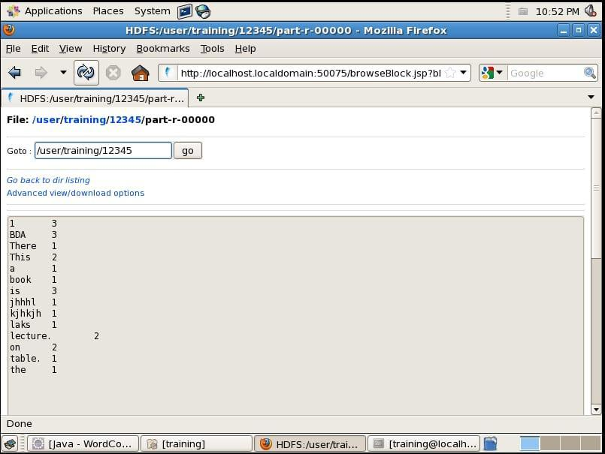

**Conclusion**

Understood and implemented word count of a document by MapReduce method

EXPERIMENT - 4

**AIM**: Execute HIVE commands to load, insert, retrieve, update, or delete data in the tables.

**THEORY**:

Apache Hive is a data warehouse and an ETL tool which provides an SQL-like interface between the user and the Hadoop distributed file system (HDFS) which integrates Hadoop. It is built on top of Hadoop. It is a software project that provides data query and analysis. It facilitates reading, writing and handling wide datasets stored in distributed storage and queried by Structure Query Language (SQL) syntax. It is not built for Online Transactional Processing (OLTP) workloads. It is frequently used for data warehousing tasks like data encapsulation, Ad-hoc Queries, and analysis of huge datasets. It is designed to enhance scalability, extensibility, performance, fault-tolerance and loose-coupling with its input formats.

Initially Hive is developed by Facebook and Amazon, Netflix and It delivers standard SQL functionality for analytics. Traditional SQL queries are written in the MapReduce Java API to execute SQL Application and SQL queries over distributed data. Hive provides portability as most data warehousing applications functions with SQL-based query languages like NoSQL.

**Components of Hive**:

* **HCatalog** –   
  It is a Hive component and is a table as well as a store management layer for Hadoop. It enables user along with various data processing tools like Pig and MapReduce which enables to read and write on the grid easily.
* **WebHCat** –   
  It provides a service which can be utilized by the user to run Hadoop MapReduce (or YARN), Pig, Hive tasks or function Hive metadata operations with an HTTP interface.

**Modes of Hive:**

* **Local Mode** –   
  It is used, when the Hadoop is built under pseudo mode which has only one data node, when the data size is smaller in term of restricted to single local machine, and when processing will be faster on smaller datasets existing in the local machine.
* **Map Reduce Mode** –   
  It is used, when Hadoop is built with multiple data nodes and data is divided across various nodes, it will function on huge datasets and query is executed parallelly, and to achieve enhanced performance in processing large datasets.

**Characteristics of Hive**:

* Databases and tables are built before loading the data.
* Hive as data warehouse is built to manage and query only structured data which is residing under tables.
* At the time of handling structured data, MapReduce lacks optimization and usability function such as UDFs whereas Hive framework have optimization and usability.
* Programming in Hadoop deals directly with the files. So, Hive can partition the data with directory structures to improve performance on certain queries.
* Hive is compatible for the various file formats which are TEXTFILE, SEQUENCEFILE, ORC, RCFILE, etc.
* Hive uses derby database in single user metadata storage and it uses MYSQL for multiple user Metadata or shared Metadata.

**Features of Hive:**

* It provides indexes, including bitmap indexes to accelerate the queries. Index type containing compaction and bitmap index as of 0.10.
* Metadata storage in a RDBMS, reduces the time to function semantic checks during query execution.
* Built in user-defined functions (UDFs) to manipulation of strings, dates, and other data-mining tools. Hive is reinforced to extend the UDF set to deal with the use-cases not reinforced by predefined functions.
* DEFLATE, BWT, snappy, etc are the algorithms to operation on compressed data which is stored in Hadoop Ecosystem.
* It stores schemas in a database and processes the data into the Hadoop File Distributed File System (HDFS).
* It is built for Online Analytical Processing (OLAP).
* It delivers various types of querying language which are frequently known as Hive Query Language (HVL or HiveQL).

### **Working** –

* First of all, the user submits their query and CLI sends that query to the Driver.
* Then the driver takes the help of the query compiler to check syntax.
* Then compiler requests for Metadata by sending a metadata request to Metastore.
* In response to that request, metastore sends metadata to the compiler.
* Then the compiler resends the plan to the driver after checking requirements.
* The Driver sends the plan to the execution engine.
* Execution engine sends the job to Job tracker and assigns the job to Task Tracker. Here, the query executes the MapReduce job. And in the meantime the execution engine executes metadata operations with Metastore.
* Then the execution engine fetches the results from the Data Node and sends those results to the driver.
* At last, the driver sends the results to the hive interface.

**IMPLEMENTATION:**

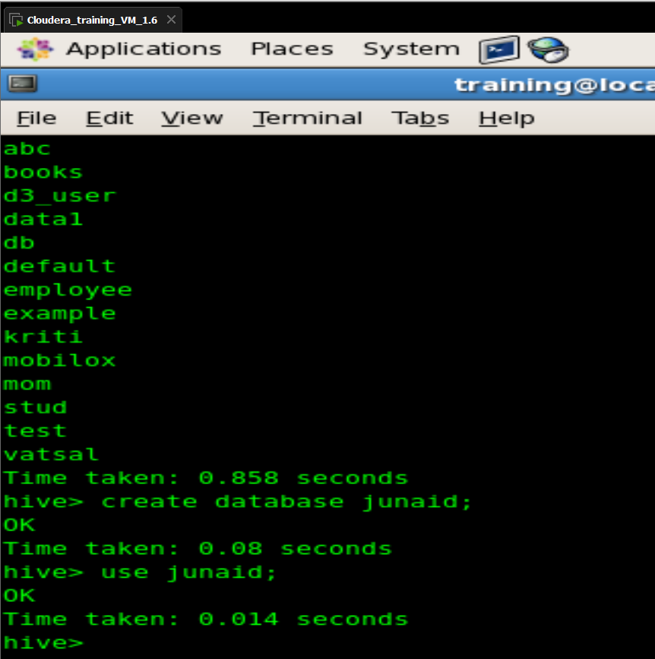

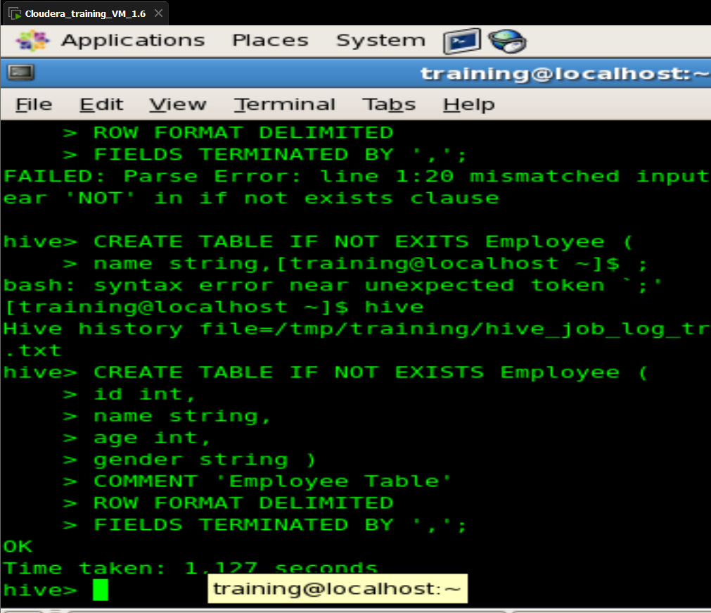

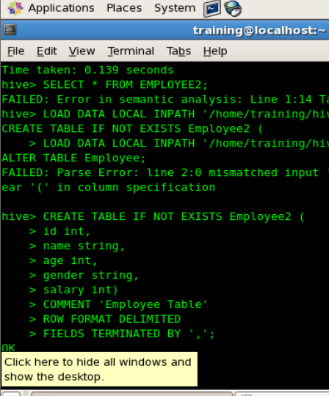

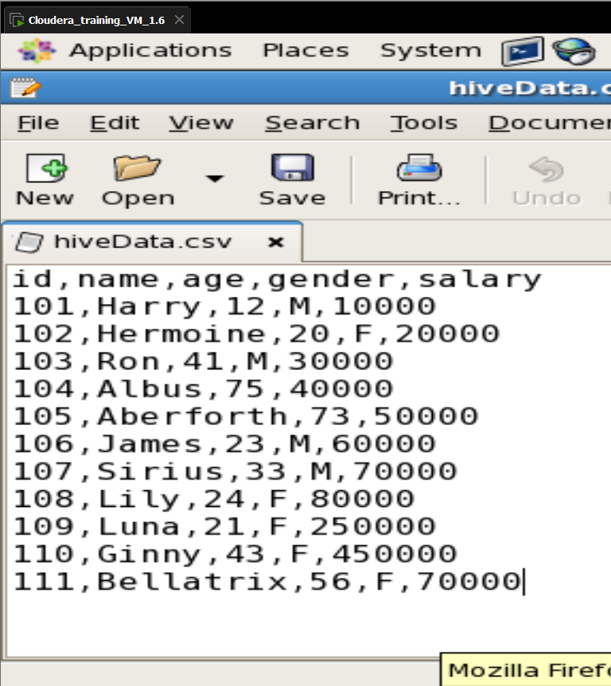

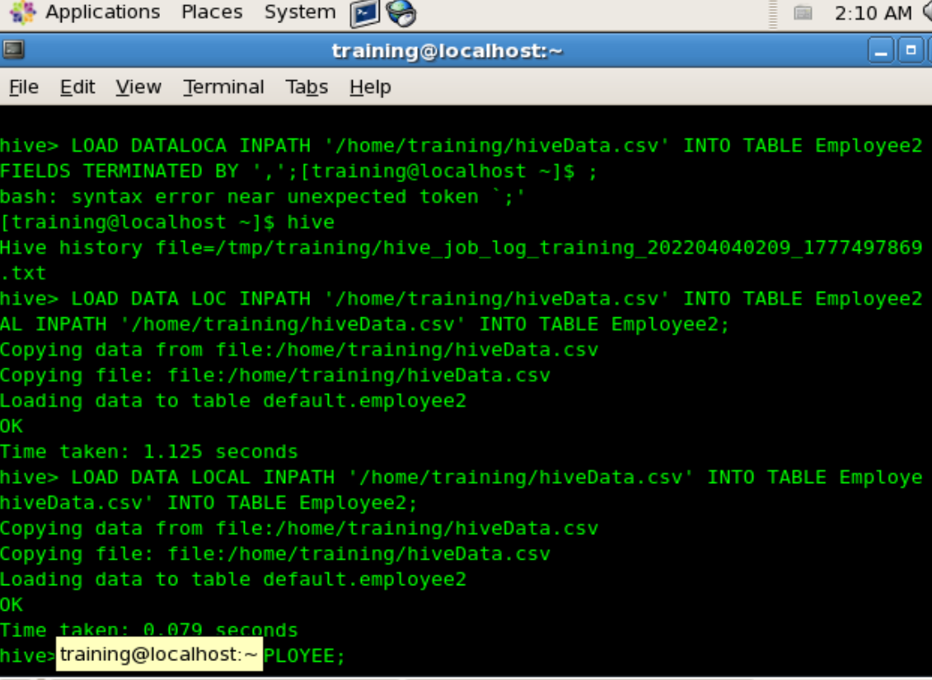

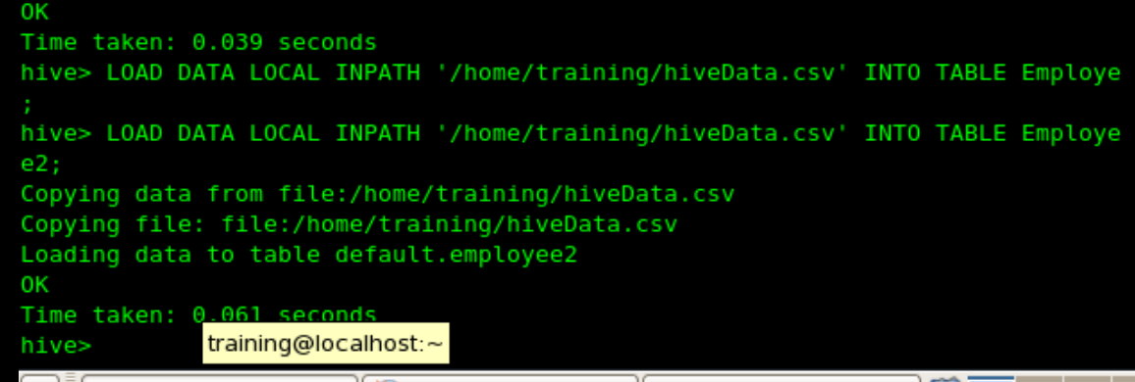

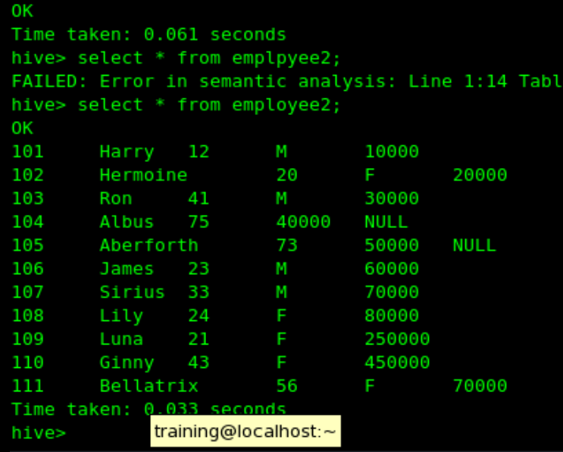

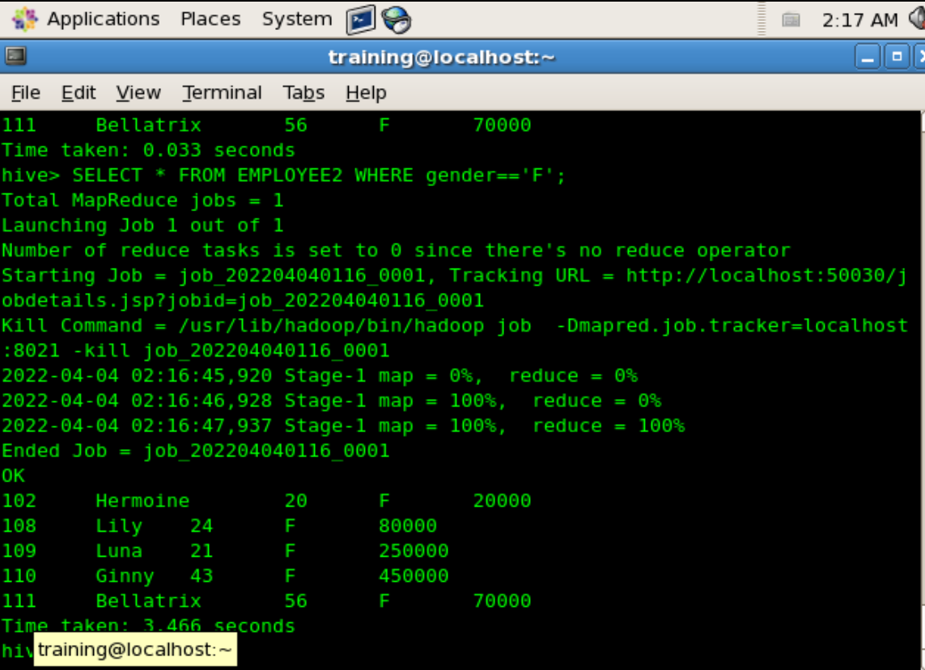

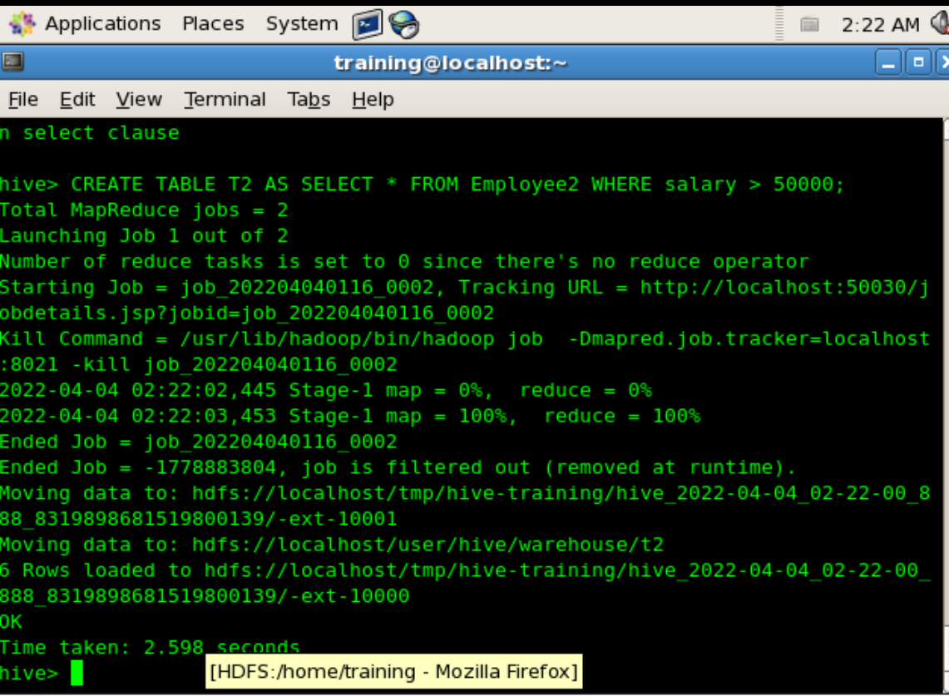

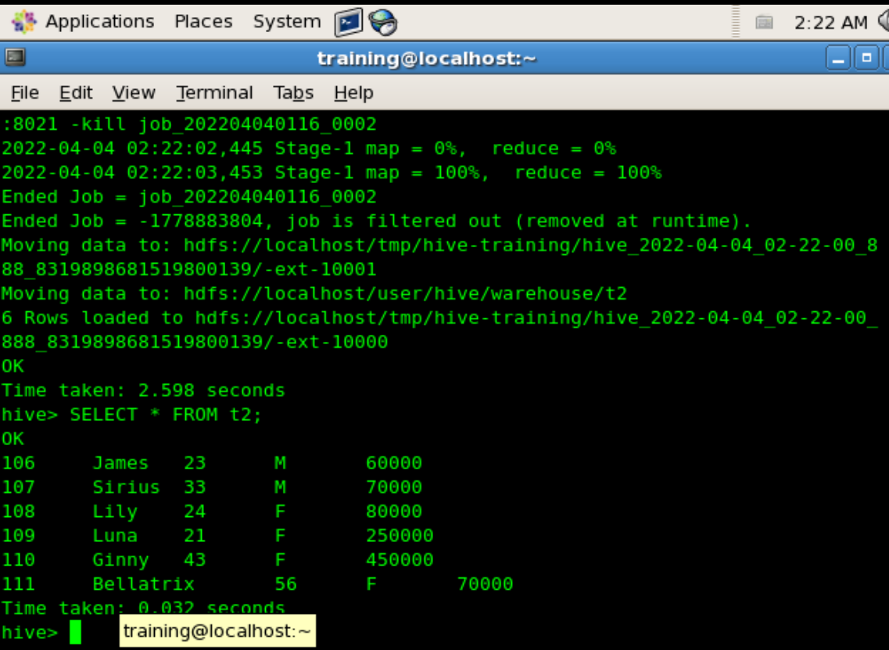

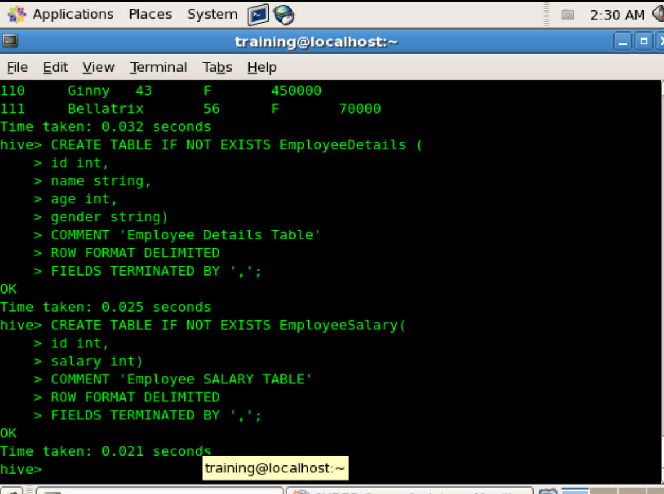

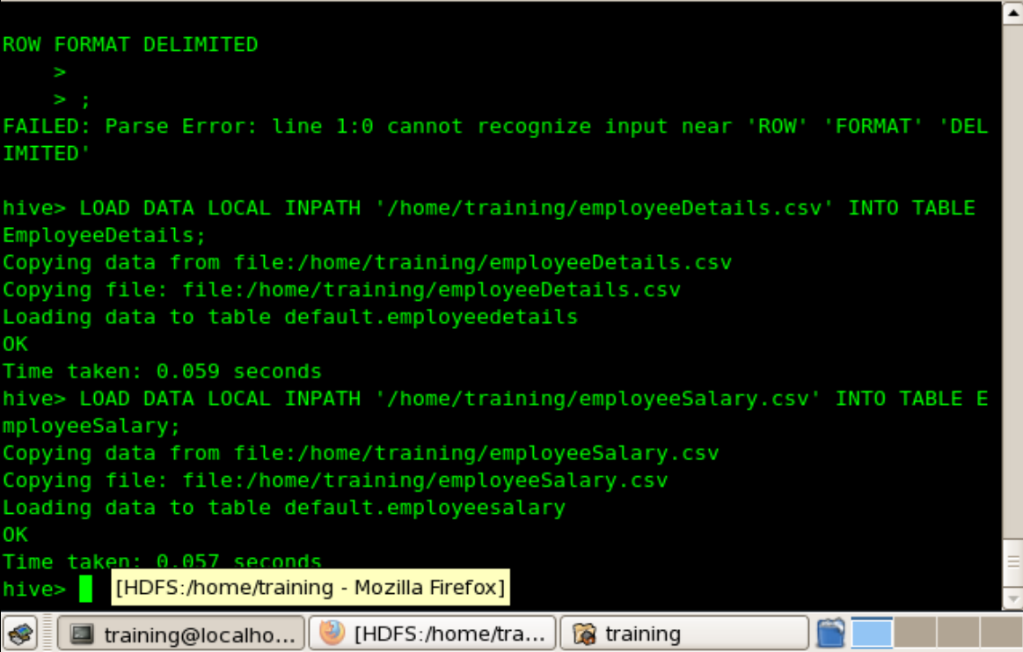

JOINS

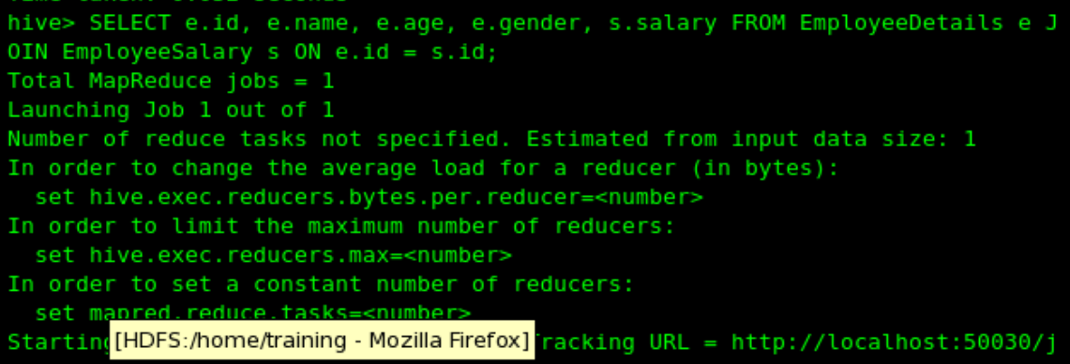

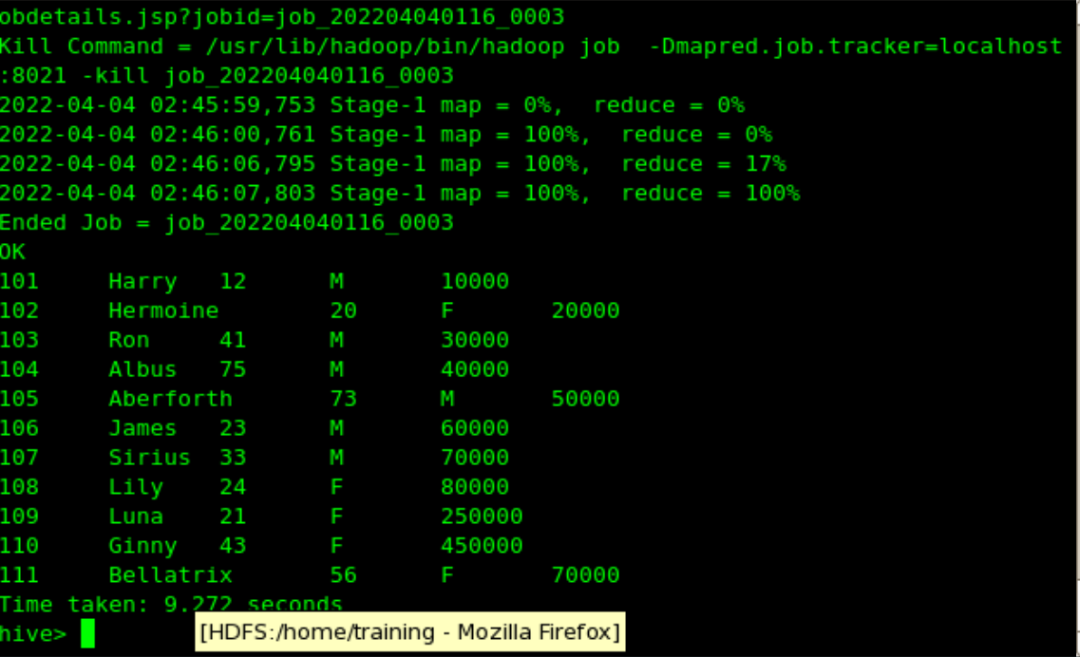

LEFT OUTER JOIN

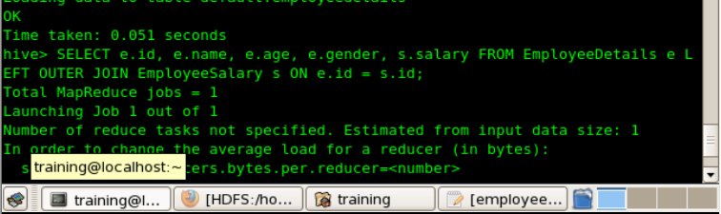

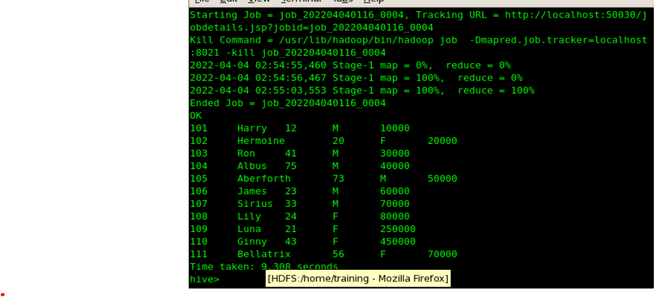

RIGHT OUTER

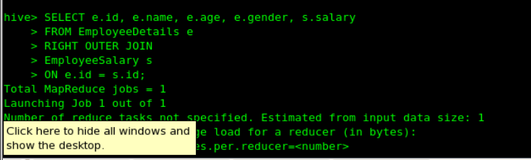

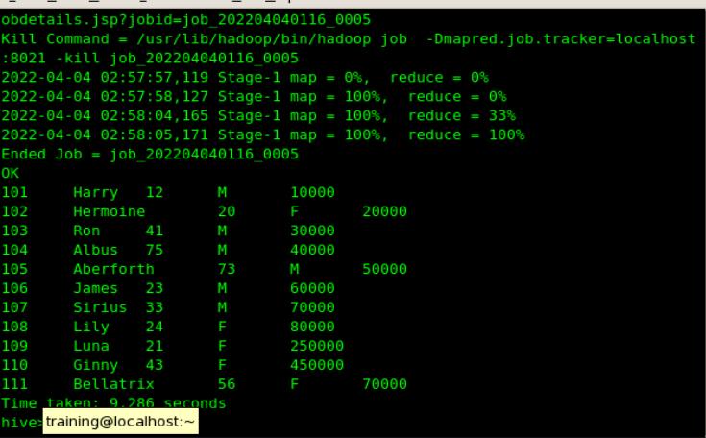

CROSS JOIN

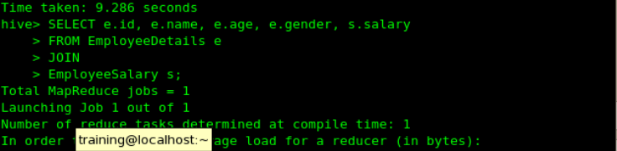

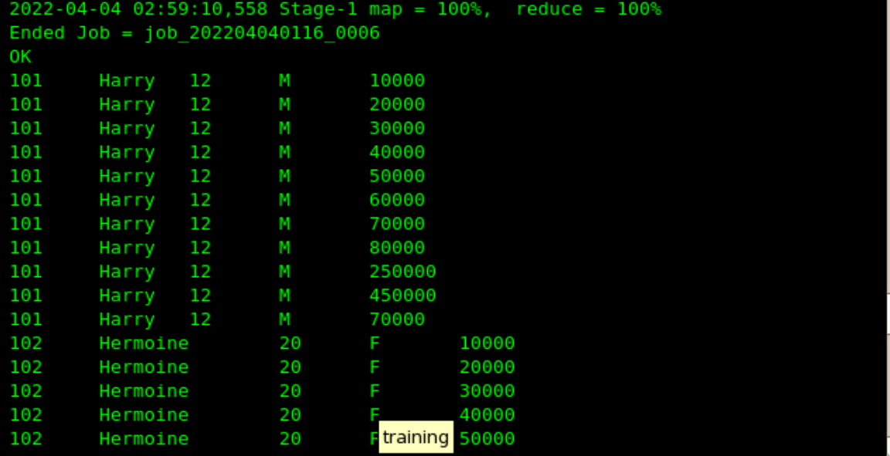

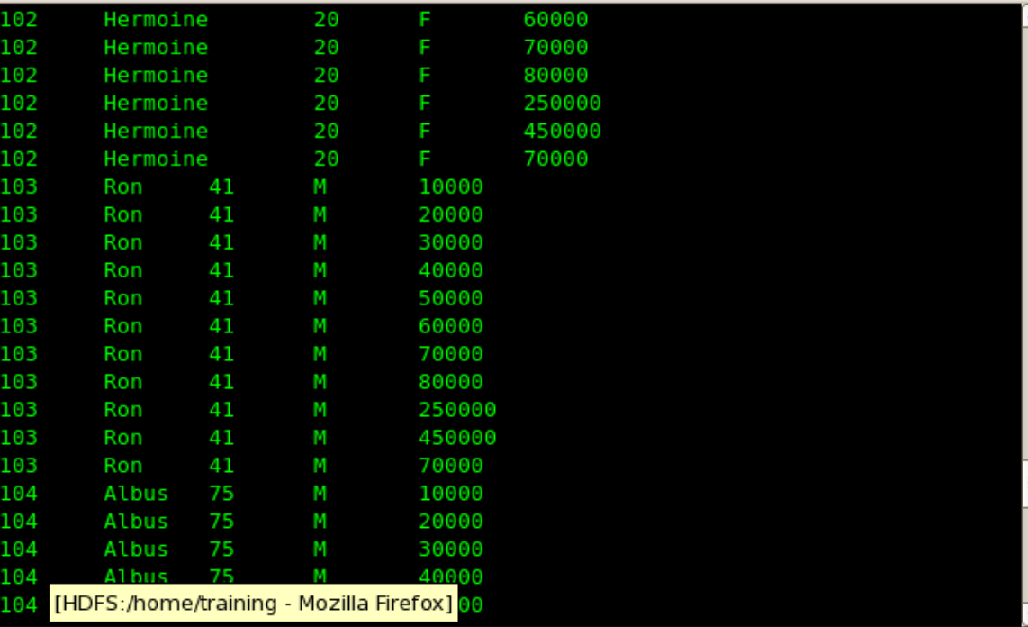

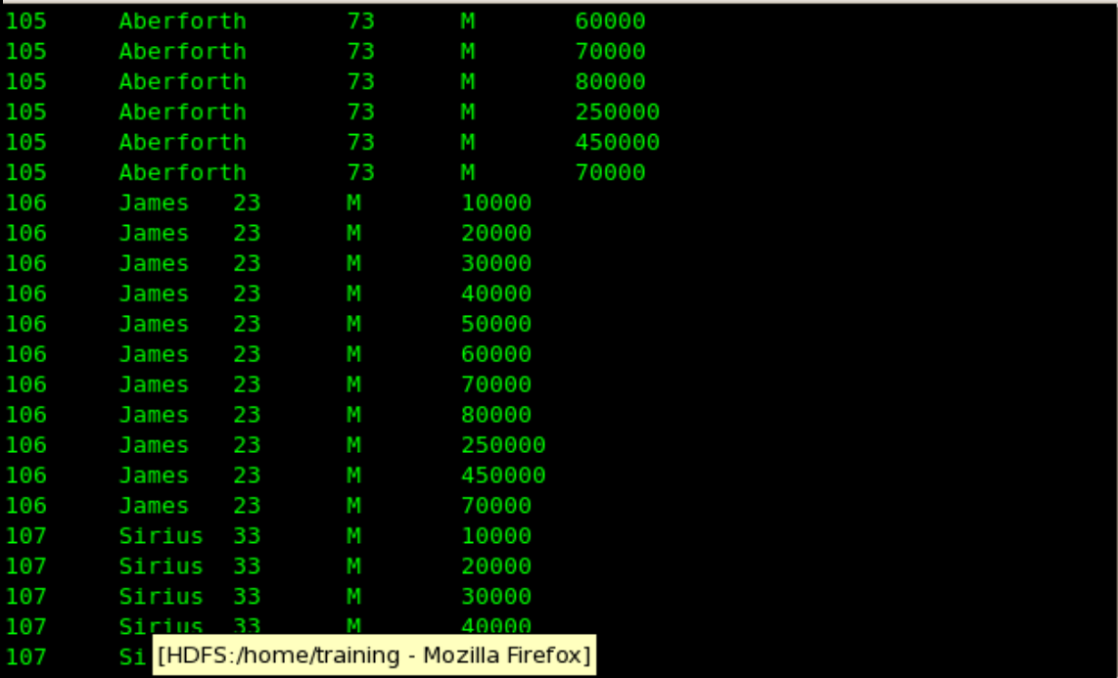

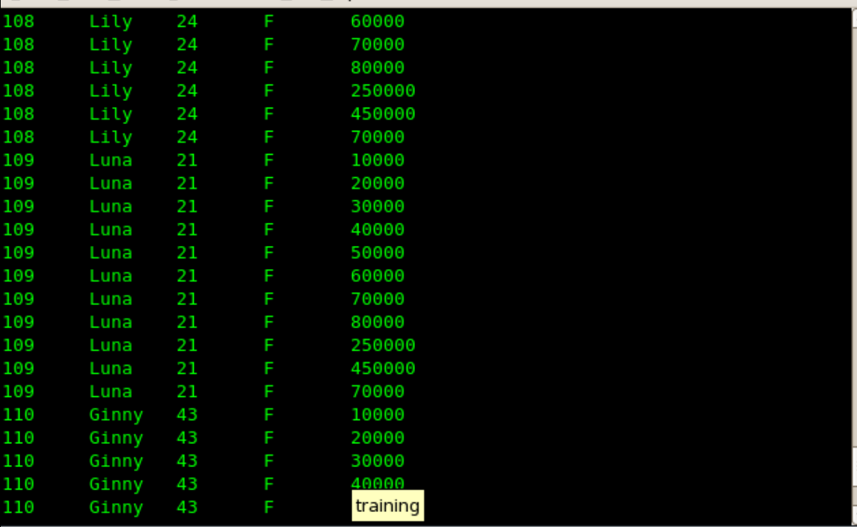

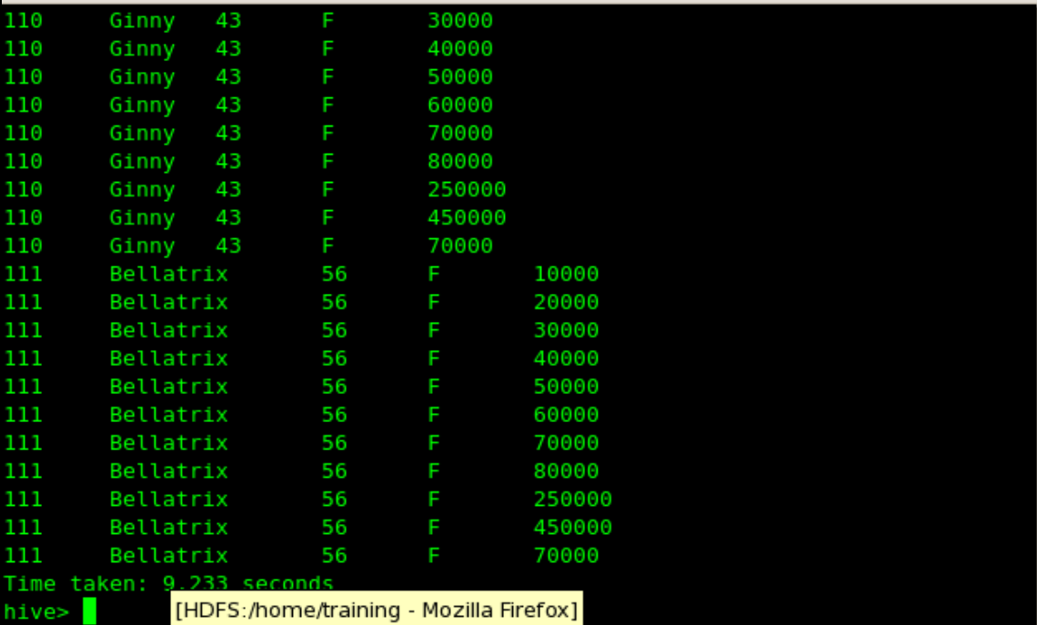

**CONCLUSION**: We have successfully executed HIVE commands to load, insert, retrieve, update, or delete data in the tables.

EXPERIMENT - 5

**AIM:** Execute HBASE commands to perform basic CRUD operations and joins

**THEORY:**

HBase is a data model that is similar to Google’s big table. It is an open source, distributed database developed by *Apache* software foundation written in Java. HBase is an essential part of our Hadoop ecosystem. HBase runs on top of HDFS (Hadoop Distributed File System). It can store massive amounts of data from terabytes to petabytes. It is column oriented and horizontally scalable.

Features of HBase – 

* It is linearly scalable across various nodes as well as modularly scalable, as it divided across various nodes.
* HBase provides consistent read and writes.
* It provides atomic read and write means during one read or write process, all other processes are prevented from performing any read or write operations.
* It provides easy to use Java API for client access.
* It supports Thrift and REST API for non-Java front ends which supports XML, Protobuf and binary data encoding options.
* It supports a Block Cache and Bloom Filters for real-time queries and for high volume query optimization.
* HBase provides automatic failure support between Region Servers.
* It support for exporting metrics with the Hadoop metrics subsystem to files.
* It doesn’t enforce relationship within your data.
* It is a platform for storing and retrieving data with random access

HBase architecture has 3 main components:

* HMaster
* Region Server
* Zookeeper.

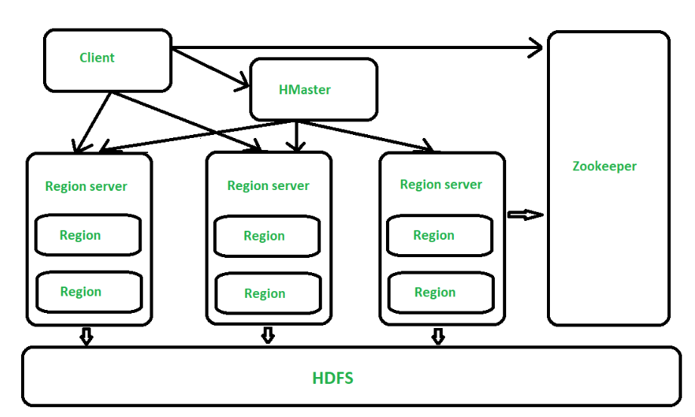

Figure – Architecture of HBase

All the 3 components are described below: 

* **HMaster** –   
  The implementation of Master Server in HBase is HMaster. It is a process in which regions are assigned to region server as well as DDL (create, delete table) operations. It monitor all Region Server instances present in the cluster. In a distributed environment, Master runs several background threads. HMaster has many features like controlling load balancing, failover etc.
* **Region Server** –   
  HBase Tables are divided horizontally by row key range into Regions. Regions are the basic building elements of HBase cluster that consists of the distribution of tables and are comprised of Column families. Region Server runs on HDFS DataNode which is present in Hadoop cluster. Regions of Region Server are responsible for several things, like handling, managing, executing as well as reads and writes HBase operations on that set of regions. The default size of a region is 256 MB.
* **Zookeeper** –   
  It is like a coordinator in HBase. It provides services like maintaining configuration information, naming, providing distributed synchronization, server failure notification etc. Clients communicate with region servers via zookeeper.

Advantages of HBase – 

* Can store large data sets
* Database can be shared
* Cost-effective from gigabytes to petabytes
* High availability through failover and replication

Disadvantages of HBase – 

* No support SQL structure
* No transaction support
* Sorted only on key
* Memory issues on the cluster

**IMPLEMENTATION:**

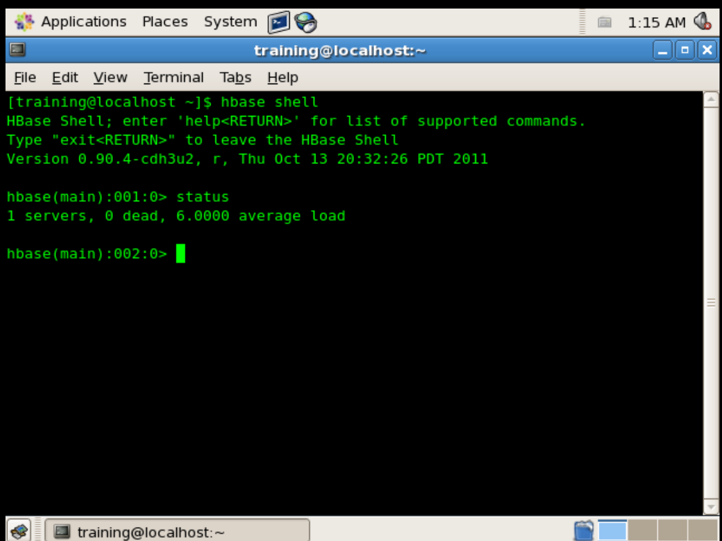

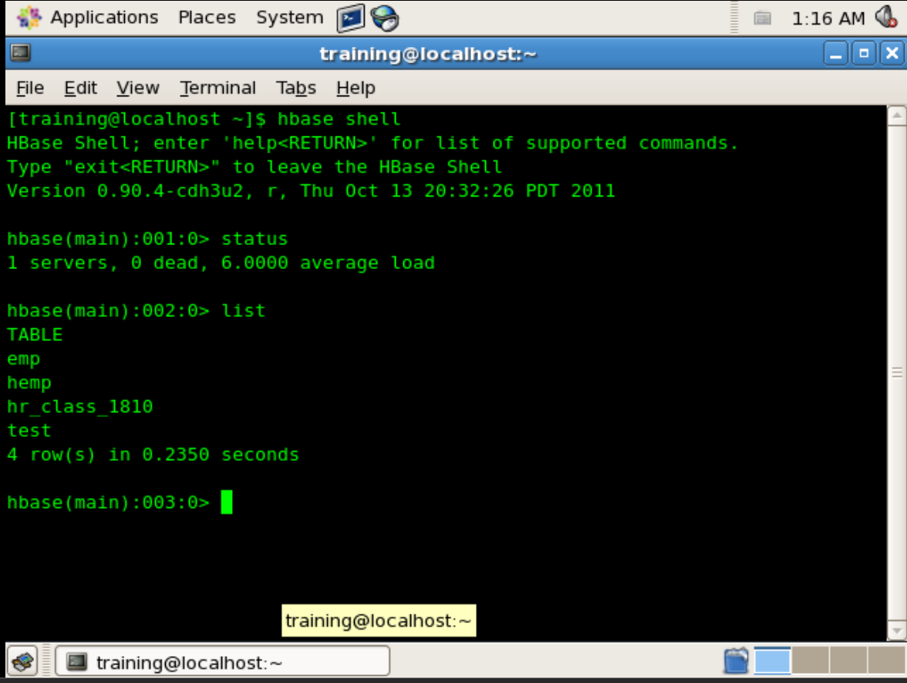

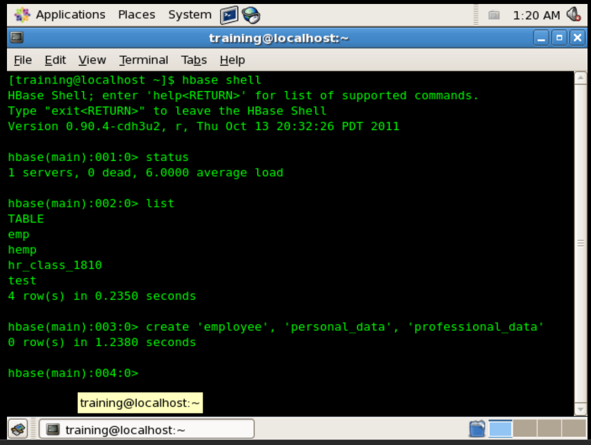

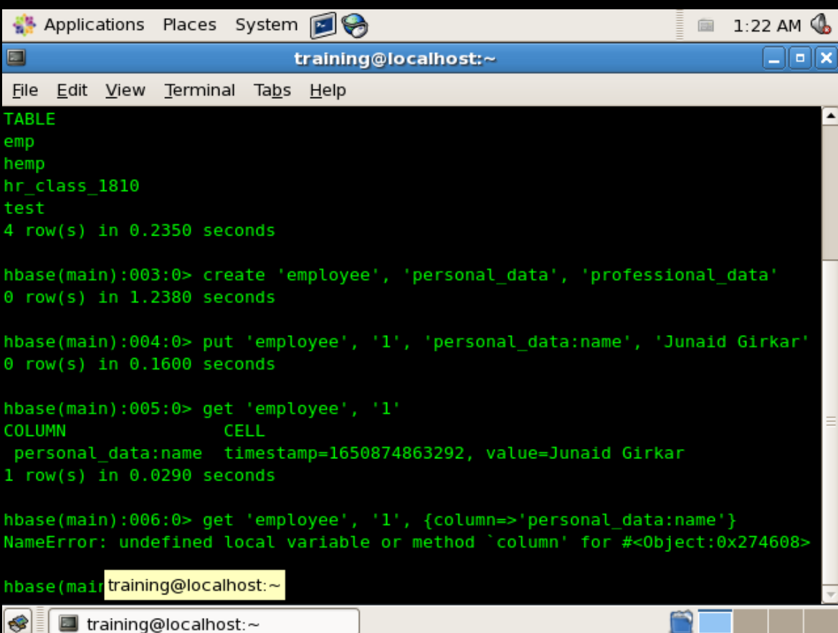

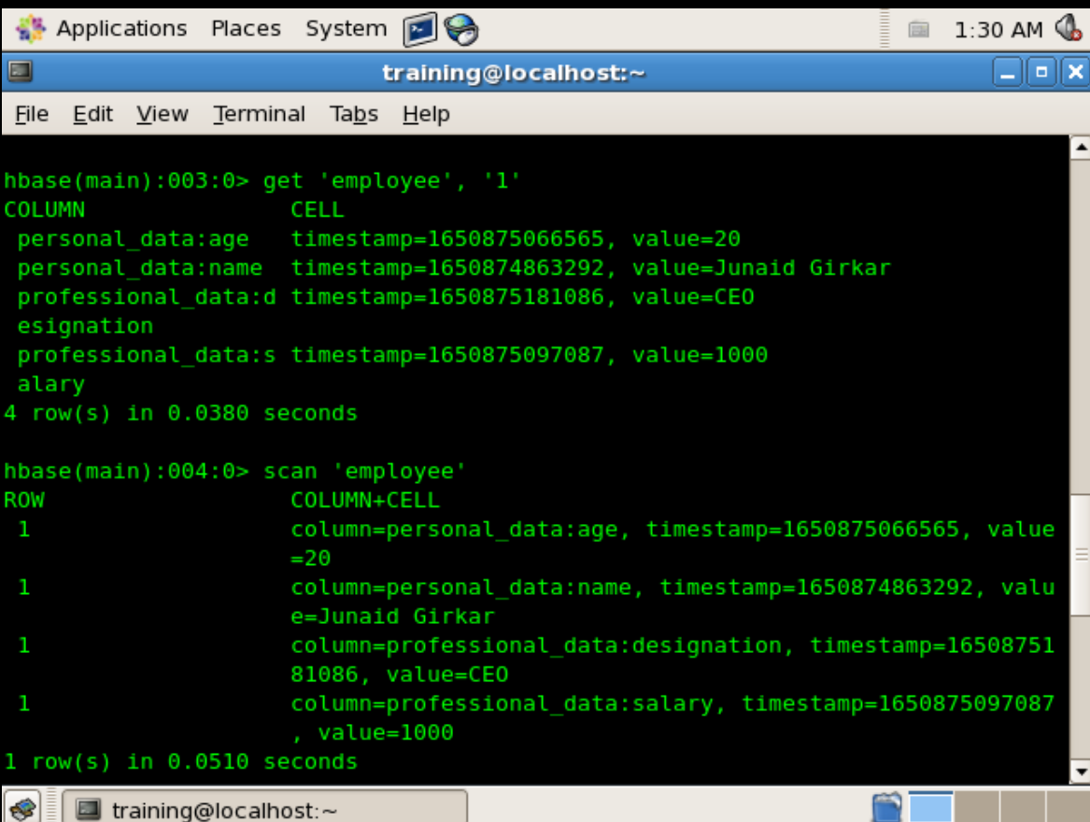

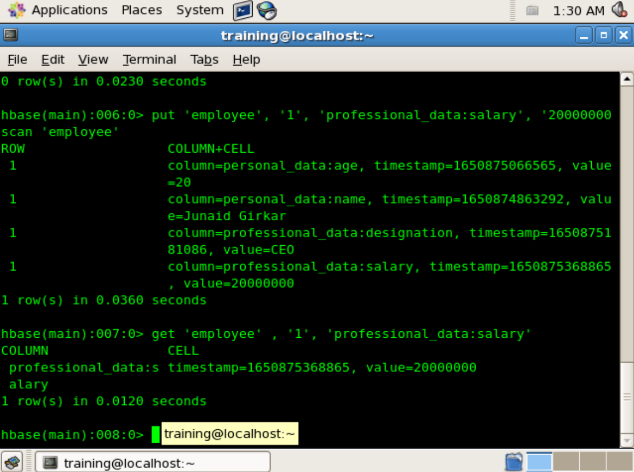

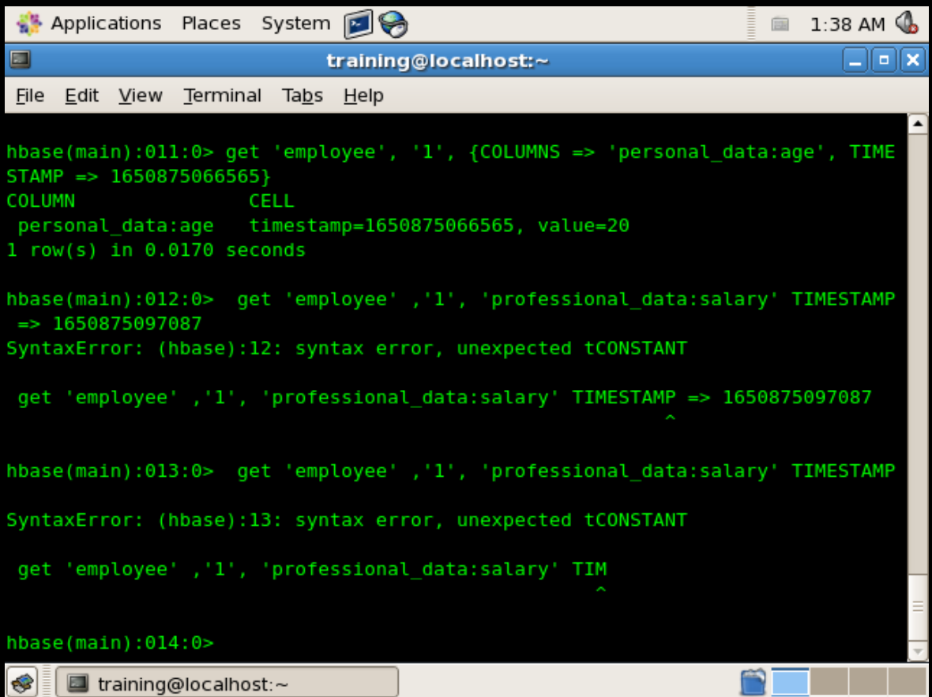

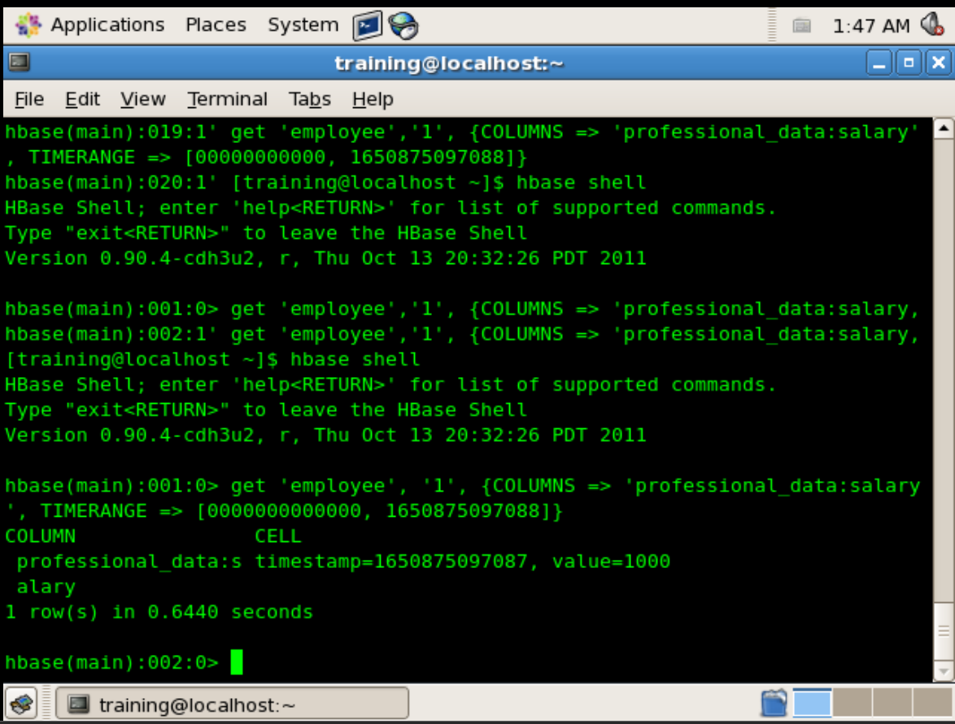

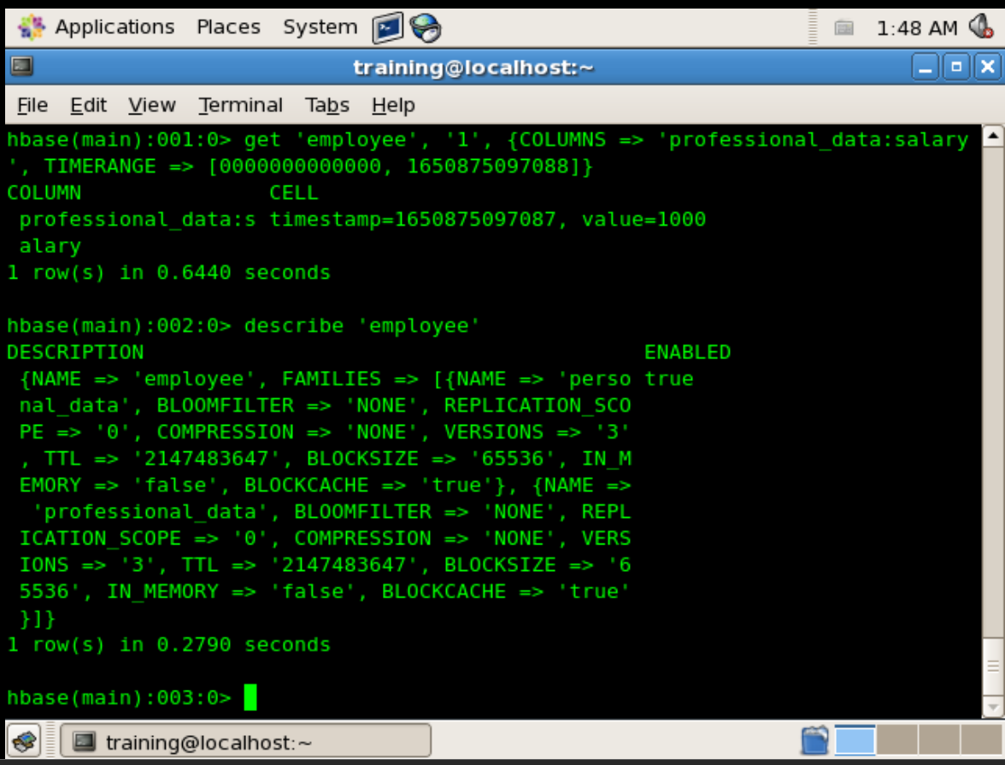

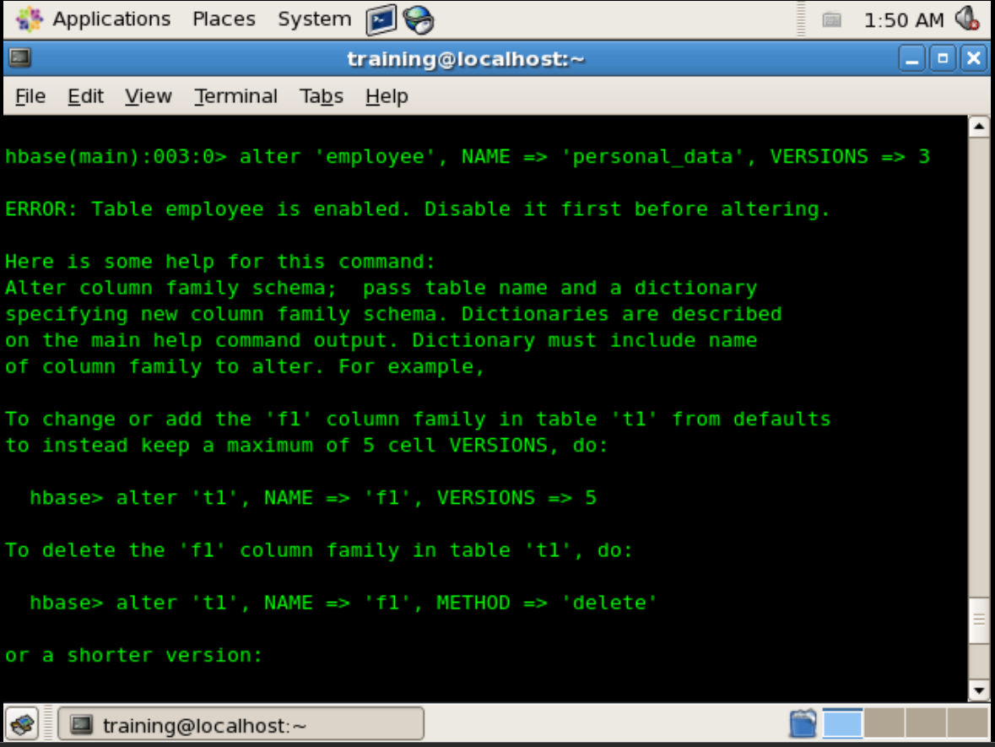

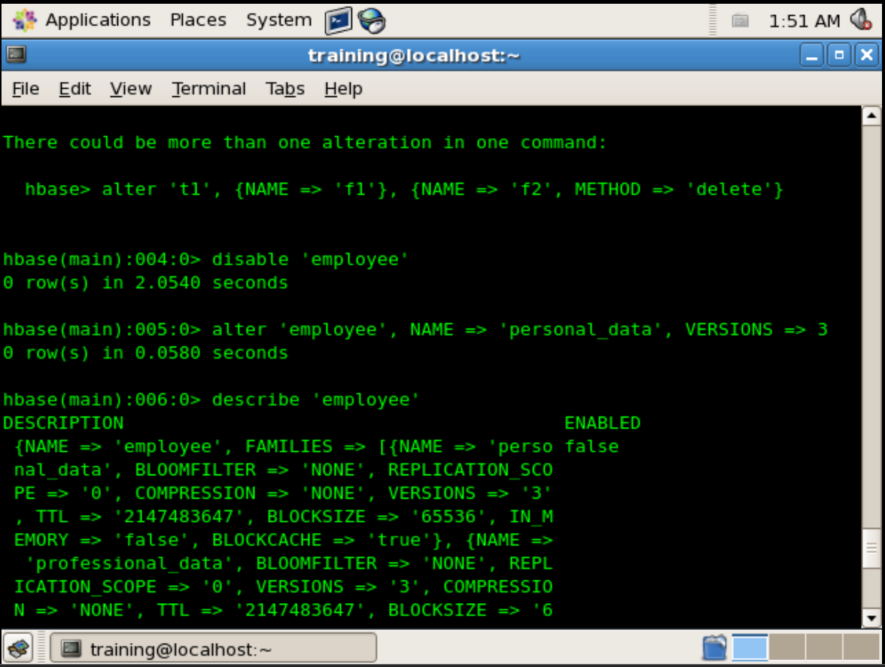

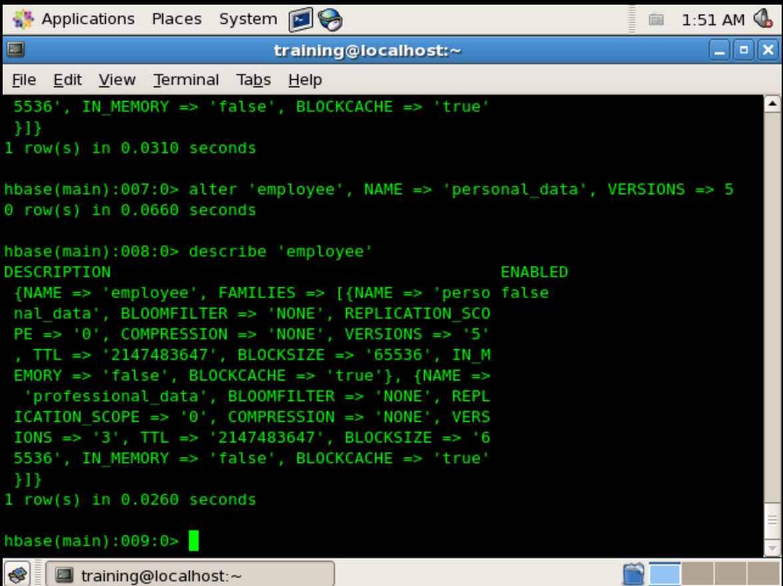

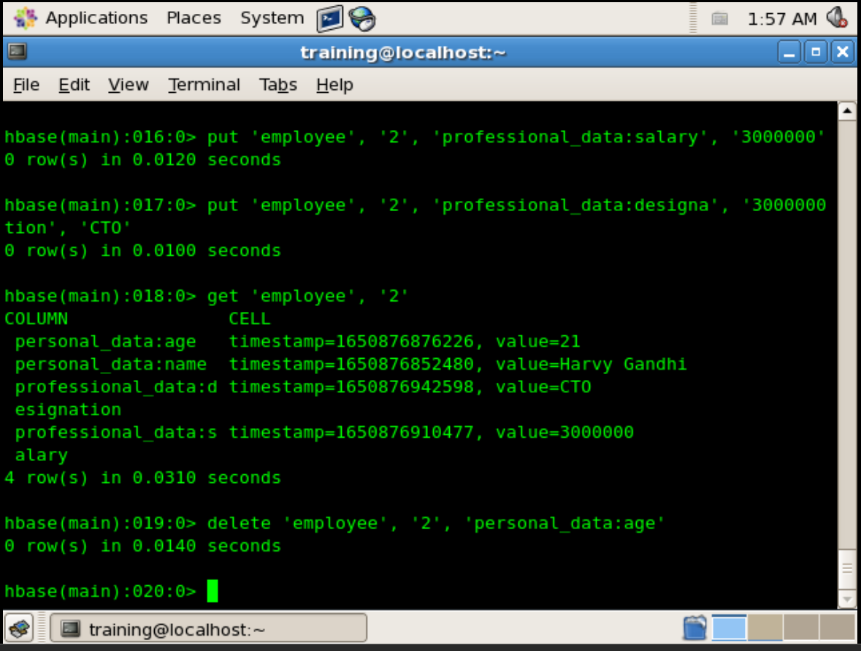

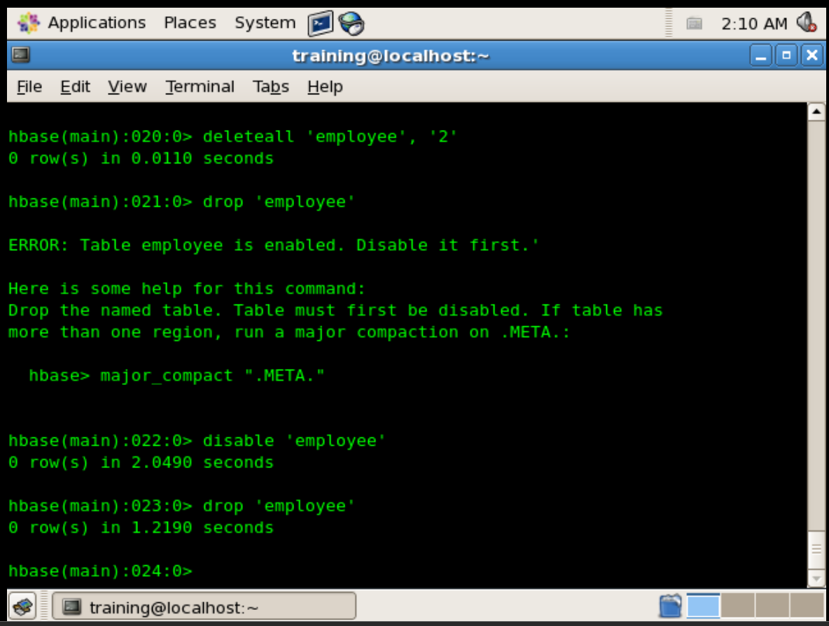

**CONCLUSION:**

Thus, in this way we have successfully implemented CRUD commands in HBase

EXPERIMENT - 6

**AIM**: Execute PIG built in commands and run pig scripts on HDFS

THEORY:

While it comes to analyse large sets of data, as well as to represent them as data flows, we use Apache Pig. It is nothing but an abstraction over MapReduce.

**What is Hadoop Pig?**

Hadoop Pig is nothing but an abstraction over MapReduce. While it comes to analyse large sets of data, as well as to represent them as data flows, we use Apache Pig. Generally, we use it with Hadoop. By using Pig, we can perform all the data manipulation operations in Hadoop.

In addition, Pig offers a high-level language to write data analysis programs which we call Pig Latin. One of the major advantages of this language is, it offers several operators.

Through them, programmers can develop their own functions for reading, writing, and processing data.  
It has following key properties such as:

* **Ease of programming**

Basically, when all the complex tasks comprised of multiple interrelated data transformations are explicitly encoded as data flow sequences, that makes them easy to write, understand, and maintain.

* **Optimization opportunities**

It allows users to focus on semantics rather than efficiency, to optimize their execution automatically, in which tasks are encoded permits the system.

* **Extensibility**

In order to do special-purpose processing, users can create their own functions.  
Hence, programmers need to write scripts using Pig Latin language to analyze data using Apache Pig.

However, all these scripts are internally converted to Map and Reduce tasks. It is possible with a component, we call as Pig Engine. That accepts the Pig Latin scripts as input and further convert those scripts into MapReduce jobs.

**Why Do We Need Apache Pig?**

While performing any MapReduce tasks, there is a case Programmers who are not so good at Java normally used to struggle to work with Hadoop. Thus, we can say, Pig is a boon for all such programmers because:

* Without having to type complex codes in Java, using Pig Latin, programmers can perform MapReduce tasks easily.
* It also helps in reduce the length of codes, since Pig uses multi-query approach. Let’s understand it with an example. Here an operation that would require us to type 200 lines of code (LoC) in Java can be easily done by typing as less as just 10 LoC in Apache Pig. Hence, it shows, Pig reduces the development time by almost 16 times.
* When you are familiar with SQL, it is easy to learn Pig. Because Pig Latin is SQL-like language.
* It offers many built-in operators, in order to support data operations such as joins, filters, ordering, and many more. Also, it offers nested data types that are missing from MapReduce such as tuples, bags, and maps.

There are several scenarios, where we can use Pig. Such as:

* While data loads are time sensitive.
* Also, while processing various data sources.
* While we require analytical insights through sampling.

**Where Not to Use Pig?**

Also, there are some Scenarios, where we can not use. Such as:

* While the data is completely unstructured. Such as video, audio, and readable text.
* Where time constraints exist. Since Pig is slower than MapReduce jobs.
* Also, when more power is required to optimize the codes, we cannot use Pig.

**Architecture of Hadoop Pig**

Here, the image, which shows the architecture of Apache Pig.

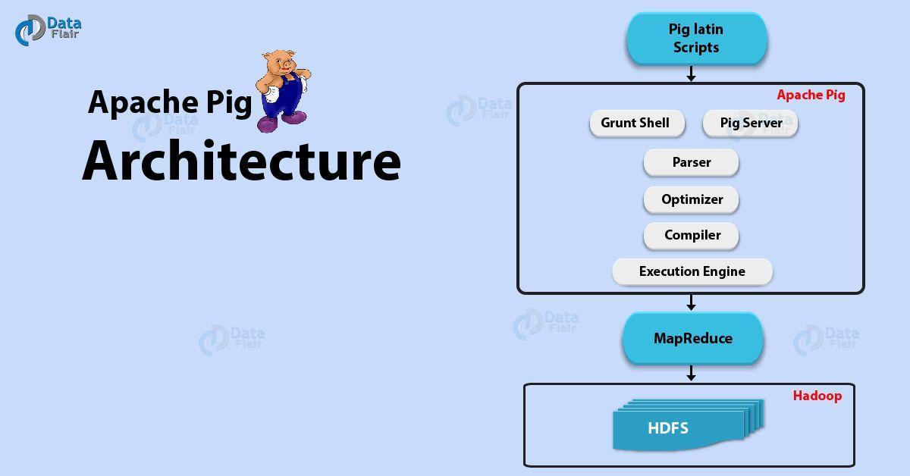

**Components of Apache Pig**

There are various components in Apache Pig Architecture which makes its execution faster as discussed below:

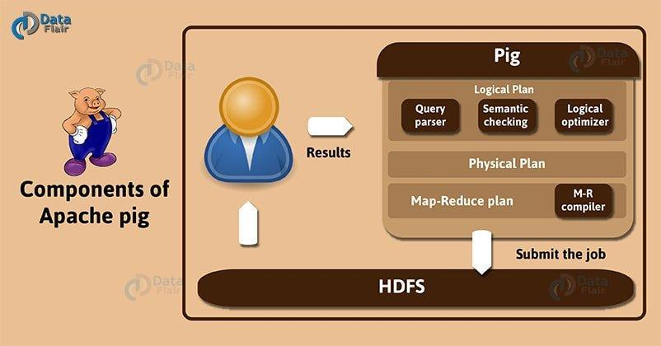

*Components of Apache Pig*

**a. Parser**

The Parser handles the Pig Scripts and checks the syntax of the script. It includes type checking with other checks. Therefore, an output of the parser will be a Directed Graph. However, it represents the Pig Latin statements and logical operators.

In the **DAG**, the script operators are actually represented as the nodes. Moreover, the data flows are eventually represented as edges.

**b. Optimizer**

The logical optimizer then receives the logical plan (DAG). In fact, it carries out the logical optimization such as projection and push down.

**c. Compiler**

The compiler converts the logical plan into a series of **MapReduce jobs**.

**d. Execution Engine**

In the end, the MapReduce jobs get submitted to Hadoop in a sorted order. Therefore these MapReduce jobs execute on the Hadoop and produce the desired results.

**Pig Latin Data Model**

There is a complete nested data model of Pig Latin. Meanwhile, it allows complex non-atomic data types such as map and tuple.

**a. Field and Atom**

Atom is a single value in Pig Latin, with any data type. The storage occurs in form of string and we can also use it as string and number. Various atomic values of Pig are int, long, float, double, chararray, and byte array.

Furthermore, any simple atomic value or data is actually considered as a field.  
For Example − ‘dataflair’ or ‘12’

**d. Tuples**

A record which contains an ordered set of fields is a Tuple. Thus, the fields can be of any type. A tuple is same as the row in a table of RDBMS.  
For Example − (Dataflair, 12)

**c. Bag**

A bag contains an unordered set of tuples. Therefore, a collection of tuples (non-unique) is can be a bag. Each tuple may have any number of fields. We can represent the bag as ‘{}’. It is same as a table in RDBMS.

However, it is not necessary that every tuple contains the same fields. Hence,  the fields in the same position (column) may not have the same type.

Example − {(Dataflair, 12), (Training, 11)}  
While a bag can be a field in a relation which is an inner bag.  
Example − {Dataflair, 12, {1212121212, dt@gmail.com,}}

**d. Map**

A map (or data map) contains the set of many key-value pairs. Meanwhile, the key has to be of type chararray and unique. The value can be of any type. We can represent it by ‘[]’.  
Example − [name#Dataflair, age#11]

**e. Relation**

Furthermore, a relation contains the bag of tuples. There may be no serial order of processing in the relations.

There are several features of Pig. Such as:

**i. Rich set of operators**

In order to perform several operations, Pig offers many operators. Such as join, sort, filer and many more.

**ii. Ease of programming**

Since you are good at SQL,  it is easy to write a Pig script. Because of Pig Latin as same as SQL.

**iii. Optimization opportunities**

In Apache Pig, all the tasks optimize their execution automatically. As a result, the programmers need to focus only on the semantics of the language.

**iv. Extensibility**

Through Pig, it is easy to read, process, and write data. It is possible by using the existing operators. Also, users can develop their own functions.

**v. UDFs**

By using Pig, we can create User-defined Functions in other programming languages like Java. Also, can invoke or embed them in Pig Scripts.

vi. Handles all kinds of data

Pig generally analyzes all kinds of data. Even both structured and unstructured. Moreover, it stores the results in HDFS.

Recommended Skills prior to learning Pig

Such as:

* Basic knowledge of Linux Operating System
* Fundamental programming skills

Applications of Pig

For performing tasks involving ad-hoc processing and quick prototyping, data scientists generally use Apache Pig. More of its applications are:

* In order to process huge data sources like weblogs.
* Also, to perform data processing for search platforms.
* Moreover, to process time sensitive data loads.

Observations:

**Uploading Data to HDFS:**

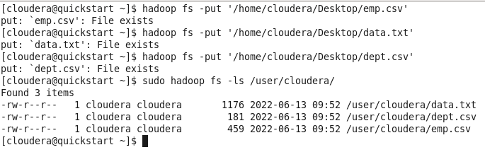

**Grunt Script 1:**

| grunt> data = LOAD '/user/cloudera/data.txt' USING PigStorage(',') as (eid:int,name:chararray,salary:int,address:chararray); 2022-06-13 10:30:39,497 [main] INFO org.apache.hadoop.conf.Configuration.deprecation - fs.default.name is deprecated. Instead, use fs.defaultFS grunt> dept = LOAD '/user/cloudera/dept.csv' USING PigStorage(',') as (did:int,dname:chararray,dhead:chararray); grunt> emp = LOAD '/user/cloudera/emp.csv' USING PigStorage(',') as (eid:int,ename:chararray,did:int,address:chararray); grunt> c = join emp by did, dept by did; grunt> dump c; |
| --- |

**Grunt Output 1:**

| 2022-06-13 10:31:22,095 [main] INFO org.apache.pig.tools.pigstats.ScriptState - Pig features used in the script: HASH_JOIN 2022-06-13 10:31:22,095 [main] INFO org.apache.pig.newplan.logical.optimizer.LogicalPlanOptimizer - {RULES_ENABLED=[AddForEach, ColumnMapKeyPrune, DuplicateForEachColumnRewrite, GroupByConstParallelSetter, ImplicitSplitInserter, LimitOptimizer, LoadTypeCastInserter, MergeFilter, MergeForEach, NewPartitionFilterOptimizer, PushDownForEachFlatten, PushUpFilter, SplitFilter, StreamTypeCastInserter], RULES_DISABLED=[FilterLogicExpressionSimplifier, PartitionFilterOptimizer]} 2022-06-13 10:31:22,101 [main] INFO org.apache.pig.backend.hadoop.executionengine.mapReduceLayer.MRCompiler - File concatenation threshold: 100 optimistic? false 2022-06-13 10:31:22,106 [main] INFO org.apache.pig.backend.hadoop.executionengine.mapReduceLayer.MRCompiler$LastInputStreamingOptimizer - Rewrite: POPackage->POForEach to POJoinPackage 2022-06-13 10:31:22,106 [main] INFO org.apache.pig.backend.hadoop.executionengine.mapReduceLayer.MultiQueryOptimizer - MR plan size before optimization: 1 2022-06-13 10:31:22,106 [main] INFO org.apache.pig.backend.hadoop.executionengine.mapReduceLayer.MultiQueryOptimizer - MR plan size after optimization: 1 2022-06-13 10:31:22,118 [main] INFO org.apache.hadoop.yarn.client.RMProxy - Connecting to ResourceManager at quickstart.cloudera/127.0.0.1:8032 2022-06-13 10:31:22,119 [main] INFO org.apache.pig.tools.pigstats.ScriptState - Pig script settings are added to the job 2022-06-13 10:31:22,127 [main] INFO org.apache.pig.backend.hadoop.executionengine.mapReduceLayer.JobControlCompiler - mapred.job.reduce.markreset.buffer.percent is not set, set to default 0.3 2022-06-13 10:31:22,127 [main] INFO org.apache.pig.backend.hadoop.executionengine.mapReduceLayer.JobControlCompiler - Reduce phase detected, estimating # of required reducers. 2022-06-13 10:31:22,128 [main] INFO org.apache.pig.backend.hadoop.executionengine.mapReduceLayer.JobControlCompiler - Using reducer estimator: org.apache.pig.backend.hadoop.executionengine.mapReduceLayer.InputSizeReducerEstimator 2022-06-13 10:31:22,131 [main] INFO org.apache.pig.backend.hadoop.executionengine.mapReduceLayer.InputSizeReducerEstimator - BytesPerReducer=1000000000 maxReducers=999 totalInputFileSize=640 2022-06-13 10:31:22,131 [main] INFO org.apache.pig.backend.hadoop.executionengine.mapReduceLayer.JobControlCompiler - Setting Parallelism to 1 2022-06-13 10:31:22,237 [main] INFO org.apache.pig.backend.hadoop.executionengine.mapReduceLayer.JobControlCompiler - creating jar file Job9137013878959109241.jar 2022-06-13 10:31:24,326 [main] INFO org.apache.pig.backend.hadoop.executionengine.mapReduceLayer.JobControlCompiler - jar file Job9137013878959109241.jar created 2022-06-13 10:31:24,332 [main] INFO org.apache.pig.backend.hadoop.executionengine.mapReduceLayer.JobControlCompiler - Setting up single store job 2022-06-13 10:31:24,332 [main] INFO org.apache.pig.data.SchemaTupleFrontend - Key [pig.schematuple] is false, will not generate code. 2022-06-13 10:31:24,332 [main] INFO org.apache.pig.data.SchemaTupleFrontend - Starting process to move generated code to distributed cache 2022-06-13 10:31:24,332 [main] INFO org.apache.pig.data.SchemaTupleFrontend - Setting key [pig.schematuple.classes] with classes to deserialize [] 2022-06-13 10:31:24,358 [main] INFO org.apache.pig.backend.hadoop.executionengine.mapReduceLayer.MapReduceLauncher - 1 map-reduce job(s) waiting for submission. 2022-06-13 10:31:24,360 [JobControl] INFO org.apache.hadoop.yarn.client.RMProxy - Connecting to ResourceManager at quickstart.cloudera/127.0.0.1:8032 2022-06-13 10:31:24,368 [JobControl] INFO org.apache.hadoop.conf.Configuration.deprecation - fs.default.name is deprecated. Instead, use fs.defaultFS 2022-06-13 10:31:24,864 [JobControl] INFO org.apache.hadoop.mapreduce.lib.input.FileInputFormat - Total input paths to process : 1 2022-06-13 10:31:24,864 [JobControl] INFO org.apache.pig.backend.hadoop.executionengine.util.MapRedUtil - Total input paths to process : 1 2022-06-13 10:31:24,866 [JobControl] INFO org.apache.pig.backend.hadoop.executionengine.util.MapRedUtil - Total input paths (combined) to process : 1 2022-06-13 10:31:24,874 [JobControl] INFO org.apache.hadoop.mapreduce.lib.input.FileInputFormat - Total input paths to process : 1 2022-06-13 10:31:24,874 [JobControl] INFO org.apache.pig.backend.hadoop.executionengine.util.MapRedUtil - Total input paths to process : 1 2022-06-13 10:31:24,876 [JobControl] INFO org.apache.pig.backend.hadoop.executionengine.util.MapRedUtil - Total input paths (combined) to process : 1 2022-06-13 10:31:24,894 [JobControl] INFO org.apache.hadoop.mapreduce.JobSubmitter - number of splits:2 2022-06-13 10:31:24,913 [JobControl] INFO org.apache.hadoop.mapreduce.JobSubmitter - Submitting tokens for job: job_1655141303825_0002 2022-06-13 10:31:24,943 [JobControl] INFO org.apache.hadoop.yarn.client.api.impl.YarnClientImpl - Submitted application application_1655141303825_0002 2022-06-13 10:31:24,945 [JobControl] INFO org.apache.hadoop.mapreduce.Job - The url to track the job: http://quickstart.cloudera:8088/proxy/application_1655141303825_0002/ 2022-06-13 10:31:24,946 [main] INFO org.apache.pig.backend.hadoop.executionengine.mapReduceLayer.MapReduceLauncher - HadoopJobId: job_1655141303825_0002 2022-06-13 10:31:24,946 [main] INFO org.apache.pig.backend.hadoop.executionengine.mapReduceLayer.MapReduceLauncher - Processing aliases c,dept,emp 2022-06-13 10:31:24,946 [main] INFO org.apache.pig.backend.hadoop.executionengine.mapReduceLayer.MapReduceLauncher - detailed locations: M: dept[14,7],dept[-1,-1],c[16,4],emp[15,6],emp[-1,-1],c[16,4] C: R:  2022-06-13 10:31:24,963 [main] INFO org.apache.pig.backend.hadoop.executionengine.mapReduceLayer.MapReduceLauncher - 0% complete 2022-06-13 10:31:32,268 [main] INFO org.apache.pig.backend.hadoop.executionengine.mapReduceLayer.MapReduceLauncher - 50% complete 2022-06-13 10:31:40,115 [main] INFO org.apache.pig.backend.hadoop.executionengine.mapReduceLayer.MapReduceLauncher - 100% complete 2022-06-13 10:31:40,115 [main] INFO org.apache.pig.tools.pigstats.SimplePigStats - Script Statistics:   HadoopVersion PigVersion UserId StartedAt FinishedAt Features 2.6.0-cdh5.13.0 0.12.0-cdh5.13.0 cloudera 2022-06-13 10:31:22 2022-06-13 10:31:40 HASH_JOIN  Success!  Job Stats (time in seconds): JobId Maps Reduces MaxMapTime MinMapTIme AvgMapTime MedianMapTime MaxReduceTime MinReduceTime AvgReduceTime MedianReducetime Alias Feature Outputs job_1655141303825_0002 2 1 1 1 1 1 1 1 1 1 c,dept,emp HASH_JOIN hdfs://quickstart.cloudera:8020/tmp/temp-1655937455/tmp596918191,  Input(s): Successfully read 7 records from: "/user/cloudera/dept.csv" Successfully read 17 records from: "/user/cloudera/emp.csv"  Output(s): Successfully stored 16 records (969 bytes) in: "hdfs://quickstart.cloudera:8020/tmp/temp-1655937455/tmp596918191"  Counters: Total records written : 16 Total bytes written : 969 Spillable Memory Manager spill count : 0 Total bags proactively spilled: 0 Total records proactively spilled: 0  Job DAG: job_1655141303825_0002   2022-06-13 10:31:40,165 [main] WARN org.apache.pig.backend.hadoop.executionengine.mapReduceLayer.MapReduceLauncher - Encountered Warning FIELD_DISCARDED_TYPE_CONVERSION_FAILED 3 time(s). 2022-06-13 10:31:40,165 [main] INFO org.apache.pig.backend.hadoop.executionengine.mapReduceLayer.MapReduceLauncher - Success! 2022-06-13 10:31:40,167 [main] INFO org.apache.hadoop.conf.Configuration.deprecation - fs.default.name is deprecated. Instead, use fs.defaultFS 2022-06-13 10:31:40,167 [main] INFO org.apache.pig.data.SchemaTupleBackend - Key [pig.schematuple] was not set... will not generate code. 2022-06-13 10:31:40,177 [main] INFO org.apache.hadoop.mapreduce.lib.input.FileInputFormat - Total input paths to process : 1 2022-06-13 10:31:40,177 [main] INFO org.apache.pig.backend.hadoop.executionengine.util.MapRedUtil - Total input paths to process : 1 (11,Maninder Kahlon,1,Delhi,1,Sales,Maninder Kahlon) (1,Jagjit Singh,1,Delhi,1,Sales,Maninder Kahlon) (2,Hardeep Kakkar,1,Delhi,1,Sales,Maninder Kahlon) (3,Akshay Singhaniya,2,Delhi,2,Marketing,Manjot Dhillon) (12,Manjot Dhillon,2,Mumbai,2,Marketing,Manjot Dhillon) (4,Shalini Mittal,2,Punjab,2,Marketing,Manjot Dhillon) (6,Sakshi Malhotra,3,Mumbai,3,Technical,Mustafa Zahid) (5,Abeer Arora,3,Mumbai,3,Technical,Mustafa Zahid) (13,Mustafa Zahid,3,Banglore,3,Technical,Mustafa Zahid) (10,Jaspinder Narula,4,Punjab,4,Operations,Neha Sharma) (14,Neha Sharma,4,Delhi,4,Operations,Neha Sharma) (7,Ramesh Kumar,4,Banglore,4,Operations,Neha Sharma) (8,Harjinder Kumar,5,Banglore,5,Legal,Kareem Khurana) (15,Kareem Khurana,5,Punjab,5,Legal,Kareem Khurana) (16,Anubhav Bassi,6,Delhi,6,Customer Care,Anubhav Bassi) (9,Harneet Kaur,6,Punjab,6,Customer Care,Anubhav Bassi) |
| --- |

**Grunt Script 2:**

| grunt> p = foreach c generate emp::address; grunt> n = filter emp by (address == 'Delhi'); grunt> m = filter emp by (address matches '*.l*.'); grunt> x = foreach emp Generate (int)$0 +1, ename; grunt> c = cross emp, dept; grunt> STORE x into 'finaloutput'; |
| --- |

**Grunt Output 2:**

| 2022-06-13 10:34:49,466 [main] INFO org.apache.pig.tools.pigstats.ScriptState - Pig features used in the script: UNKNOWN 2022-06-13 10:34:49,467 [main] INFO org.apache.pig.newplan.logical.optimizer.LogicalPlanOptimizer - {RULES_ENABLED=[AddForEach, ColumnMapKeyPrune, DuplicateForEachColumnRewrite, GroupByConstParallelSetter, ImplicitSplitInserter, LimitOptimizer, LoadTypeCastInserter, MergeFilter, MergeForEach, NewPartitionFilterOptimizer, PushDownForEachFlatten, PushUpFilter, SplitFilter, StreamTypeCastInserter], RULES_DISABLED=[FilterLogicExpressionSimplifier, PartitionFilterOptimizer]} 2022-06-13 10:34:49,467 [main] INFO org.apache.pig.newplan.logical.rules.ColumnPruneVisitor - Columns pruned for emp: $2, $3 2022-06-13 10:34:49,470 [main] INFO org.apache.pig.backend.hadoop.executionengine.mapReduceLayer.MRCompiler - File concatenation threshold: 100 optimistic? false 2022-06-13 10:34:49,470 [main] INFO org.apache.pig.backend.hadoop.executionengine.mapReduceLayer.MultiQueryOptimizer - MR plan size before optimization: 1 2022-06-13 10:34:49,470 [main] INFO org.apache.pig.backend.hadoop.executionengine.mapReduceLayer.MultiQueryOptimizer - MR plan size after optimization: 1 2022-06-13 10:34:49,482 [main] INFO org.apache.hadoop.yarn.client.RMProxy - Connecting to ResourceManager at quickstart.cloudera/127.0.0.1:8032 2022-06-13 10:34:49,483 [main] INFO org.apache.pig.tools.pigstats.ScriptState - Pig script settings are added to the job 2022-06-13 10:34:49,487 [main] INFO org.apache.pig.backend.hadoop.executionengine.mapReduceLayer.JobControlCompiler - mapred.job.reduce.markreset.buffer.percent is not set, set to default 0.3 2022-06-13 10:34:49,590 [main] INFO org.apache.pig.backend.hadoop.executionengine.mapReduceLayer.JobControlCompiler - creating jar file Job8565394627470248938.jar 2022-06-13 10:34:51,678 [main] INFO org.apache.pig.backend.hadoop.executionengine.mapReduceLayer.JobControlCompiler - jar file Job8565394627470248938.jar created 2022-06-13 10:34:51,682 [main] INFO org.apache.pig.backend.hadoop.executionengine.mapReduceLayer.JobControlCompiler - Setting up single store job 2022-06-13 10:34:51,682 [main] INFO org.apache.pig.data.SchemaTupleFrontend - Key [pig.schematuple] is false, will not generate code. 2022-06-13 10:34:51,682 [main] INFO org.apache.pig.data.SchemaTupleFrontend - Starting process to move generated code to distributed cache 2022-06-13 10:34:51,682 [main] INFO org.apache.pig.data.SchemaTupleFrontend - Setting key [pig.schematuple.classes] with classes to deserialize [] 2022-06-13 10:34:51,687 [main] INFO org.apache.pig.backend.hadoop.executionengine.mapReduceLayer.MapReduceLauncher - 1 map-reduce job(s) waiting for submission. 2022-06-13 10:34:51,689 [JobControl] INFO org.apache.hadoop.yarn.client.RMProxy - Connecting to ResourceManager at quickstart.cloudera/127.0.0.1:8032 2022-06-13 10:34:51,691 [JobControl] INFO org.apache.hadoop.conf.Configuration.deprecation - fs.default.name is deprecated. Instead, use fs.defaultFS 2022-06-13 10:34:51,743 [JobControl] INFO org.apache.hadoop.mapreduce.lib.input.FileInputFormat - Total input paths to process : 1 2022-06-13 10:34:51,743 [JobControl] INFO org.apache.pig.backend.hadoop.executionengine.util.MapRedUtil - Total input paths to process : 1 2022-06-13 10:34:51,745 [JobControl] INFO org.apache.pig.backend.hadoop.executionengine.util.MapRedUtil - Total input paths (combined) to process : 1 2022-06-13 10:34:51,760 [JobControl] INFO org.apache.hadoop.mapreduce.JobSubmitter - number of splits:1 2022-06-13 10:34:51,773 [JobControl] INFO org.apache.hadoop.mapreduce.JobSubmitter - Submitting tokens for job: job_1655141303825_0003 2022-06-13 10:34:51,798 [JobControl] INFO org.apache.hadoop.yarn.client.api.impl.YarnClientImpl - Submitted application application_1655141303825_0003 2022-06-13 10:34:51,801 [JobControl] INFO org.apache.hadoop.mapreduce.Job - The url to track the job: http://quickstart.cloudera:8088/proxy/application_1655141303825_0003/ 2022-06-13 10:34:52,188 [main] INFO org.apache.pig.backend.hadoop.executionengine.mapReduceLayer.MapReduceLauncher - HadoopJobId: job_1655141303825_0003 2022-06-13 10:34:52,188 [main] INFO org.apache.pig.backend.hadoop.executionengine.mapReduceLayer.MapReduceLauncher - Processing aliases emp,x 2022-06-13 10:34:52,188 [main] INFO org.apache.pig.backend.hadoop.executionengine.mapReduceLayer.MapReduceLauncher - detailed locations: M: emp[15,6],x[-1,-1] C: R:  2022-06-13 10:34:52,211 [main] INFO org.apache.pig.backend.hadoop.executionengine.mapReduceLayer.MapReduceLauncher - 0% complete 2022-06-13 10:35:00,087 [main] INFO org.apache.pig.backend.hadoop.executionengine.mapReduceLayer.MapReduceLauncher - 50% complete 2022-06-13 10:35:02,221 [main] INFO org.apache.pig.backend.hadoop.executionengine.mapReduceLayer.MapReduceLauncher - 100% complete 2022-06-13 10:35:02,221 [main] INFO org.apache.pig.tools.pigstats.SimplePigStats - Script Statistics:   HadoopVersion PigVersion UserId StartedAt FinishedAt Features 2.6.0-cdh5.13.0 0.12.0-cdh5.13.0 cloudera 2022-06-13 10:34:49 2022-06-13 10:35:02 UNKNOWN  Success!  Job Stats (time in seconds): JobId Maps Reduces MaxMapTime MinMapTIme AvgMapTime MedianMapTime MaxReduceTime MinReduceTime AvgReduceTime MedianReducetime Alias Feature Outputs job_1655141303825_0003 1 0 2 2 2 2 n/a n/a n/a n/a emp,x MAP_ONLY hdfs://quickstart.cloudera:8020/user/cloudera/finaloutput,  Input(s): Successfully read 17 records (831 bytes) from: "/user/cloudera/emp.csv"  Output(s): Successfully stored 17 records (281 bytes) in: "hdfs://quickstart.cloudera:8020/user/cloudera/finaloutput"  Counters: Total records written : 17 Total bytes written : 281 Spillable Memory Manager spill count : 0 Total bags proactively spilled: 0 Total records proactively spilled: 0  Job DAG: job_1655141303825_0003   2022-06-13 10:35:02,268 [main] WARN org.apache.pig.backend.hadoop.executionengine.mapReduceLayer.MapReduceLauncher - Encountered Warning FIELD_DISCARDED_TYPE_CONVERSION_FAILED 1 time(s). 2022-06-13 10:35:02,268 [main] INFO org.apache.pig.backend.hadoop.executionengine.mapReduceLayer.MapReduceLauncher - Success! |
| --- |

CONCLUSION:

Hence, we have seen the whole concept of Hadoop Pig. Apart from its usage, we have also seen where we cannot use it. In this experiment, we have also implemented Map Reduce functionality of Hadoop by using Pig and Pig Latin.

EXPERIMENT - 7

**AIM:** Write a program to create rdd, perform various operations and find occurrences of each word.

**THEORY:**

Apache Spark

Apache Spark is a lightning-fast cluster computing technology, designed for fast computation. It is based on Hadoop MapReduce and it extends the MapReduce model to efficiently use it for more types of computations, which includes interactive queries and stream processing. The main feature of Spark is its in-memory cluster computing that increases the processing speed of an application.

Spark is designed to cover a wide range of workloads such as batch applications, iterative algorithms, interactive queries and streaming. Apart from supporting all these workload in a respective system, it reduces the management burden of maintaining separate tools.

Evolution of Apache Spark

Spark is one of Hadoop’s sub project developed in 2009 in UC Berkeley’s AMPLab by Matei Zaharia. It was Open Sourced in 2010 under a BSD license. It was donated to Apache software foundation in 2013, and now Apache Spark has become a top level Apache project from Feb-2014.

Features of Apache Spark

Apache Spark has following features.

* Speed − Spark helps to run an application in Hadoop cluster, up to 100 times faster in memory, and 10 times faster when running on disk. This is possible by reducing number of read/write operations to disk. It stores the intermediate processing data in memory.
* Supports multiple languages − Spark provides built-in APIs in Java, Scala, or Python. Therefore, you can write applications in different languages. Spark comes up with 80 high-level operators for interactive querying.
* Advanced Analytics − Spark not only supports ‘Map’ and ‘reduce’. It also supports SQL queries, Streaming data, Machine learning (ML), and Graph algorithms.

## Resilient Distributed Datasets

Resilient Distributed Datasets (RDD) is a fundamental data structure of Spark. It is an immutable distributed collection of objects. Each dataset in RDD is divided into logical partitions, which may be computed on different nodes of the cluster. RDDs can contain any type of Python, Java, or Scala objects, including user-defined classes.

Formally, an RDD is a read-only, partitioned collection of records. RDDs can be created through deterministic operations on either data on stable storage or other RDDs. RDD is a fault-tolerant collection of elements that can be operated on in parallel.

There are two ways to create RDDs − parallelizing an existing collection in your driver program, or referencing a dataset in an external storage system, such as a shared file system, HDFS, HBase, or any data source offering a Hadoop Input Format.

Spark makes use of the concept of RDD to achieve faster and efficient MapReduce operations. Let us first discuss how MapReduce operations take place and why they are not so efficient.

Data Sharing using Spark RDD

Data sharing is slow in MapReduce due to replication, serialization, and disk IO. Most of the Hadoop applications, they spend more than 90% of the time doing HDFS read-write operations.

Recognizing this problem, researchers developed a specialized framework called Apache Spark. The key idea of spark is Resilient Distributed Datasets (RDD); it supports in-memory processing computation. This means, it stores the state of memory as an object across the jobs and the object is sharable between those jobs. Data sharing in memory is 10 to 100 times faster than network and Disk.

Let us now try to find out how iterative and interactive operations take place in Spark RDD.

Iterative Operations on Spark RDD

The illustration given below shows the iterative operations on Spark RDD. It will store intermediate results in a distributed memory instead of Stable storage (Disk) and make the system faster.

Note − If the Distributed memory (RAM) is not sufficient to store intermediate results (State of the JOB), then it will store those results on the disk.

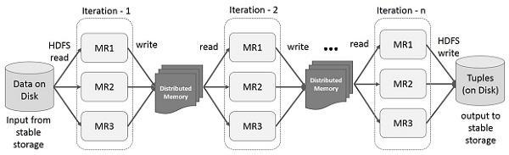

Interactive Operations on Spark RDD

This illustration shows interactive operations on Spark RDD. If different queries are run on the same set of data repeatedly, this particular data can be kept in memory for better execution times.

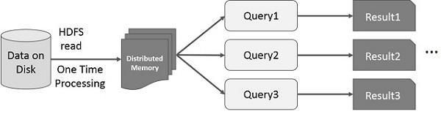

By default, each transformed RDD may be recomputed each time you run an action on it. However, you may also persist an RDD in memory, in which case Spark will keep the elements around on the cluster for much faster access, the next time you query it. There is also support for persisting RDDs on disk, or replicated across multiple nodes.

**IMPLEMENTATION:**

Part A: Operations on RDD in Spark

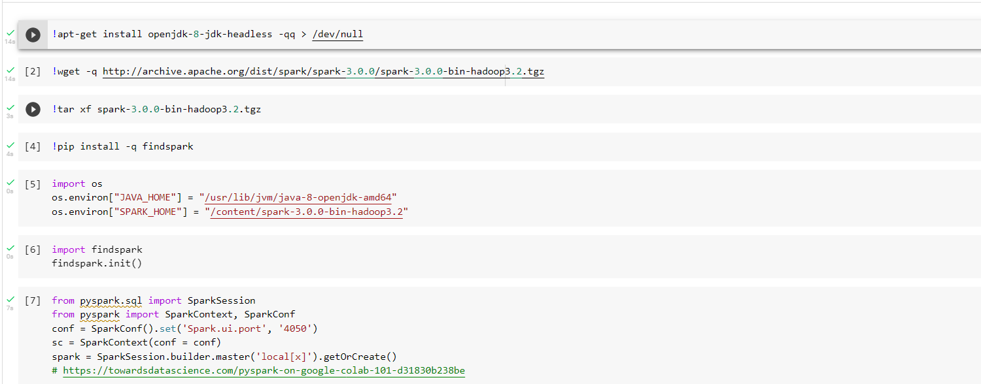

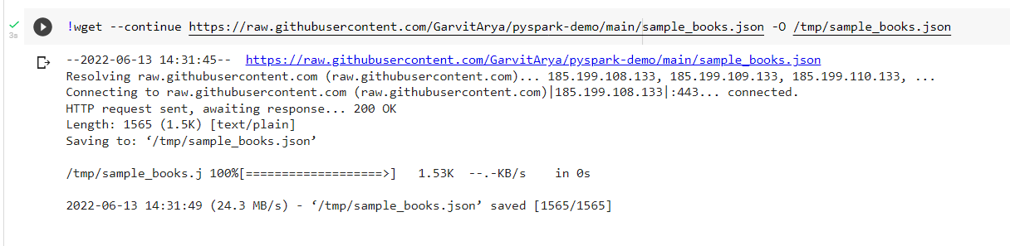

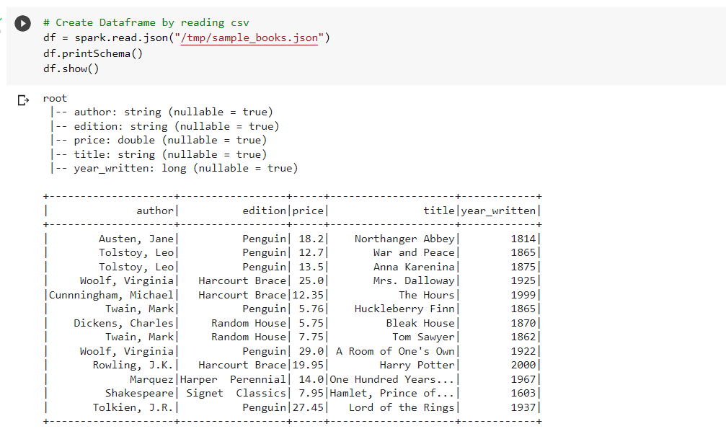

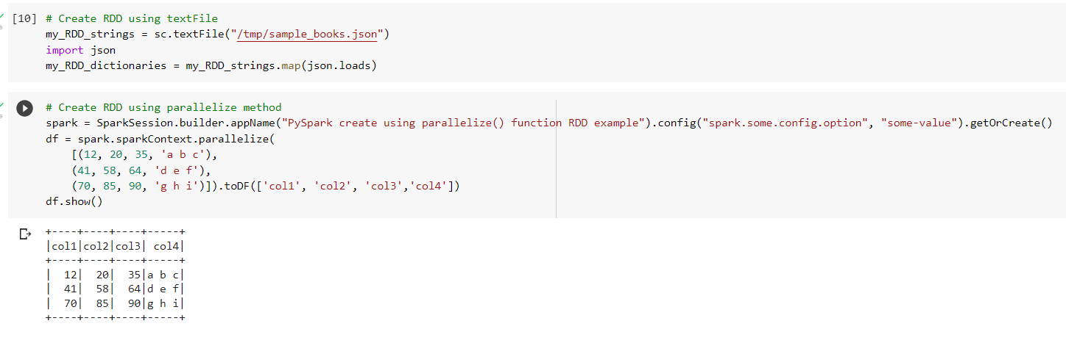

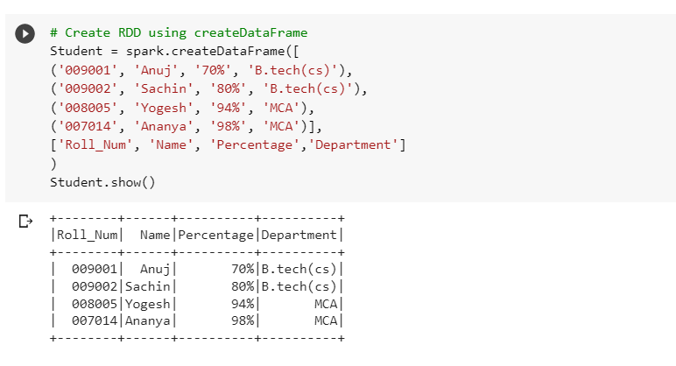

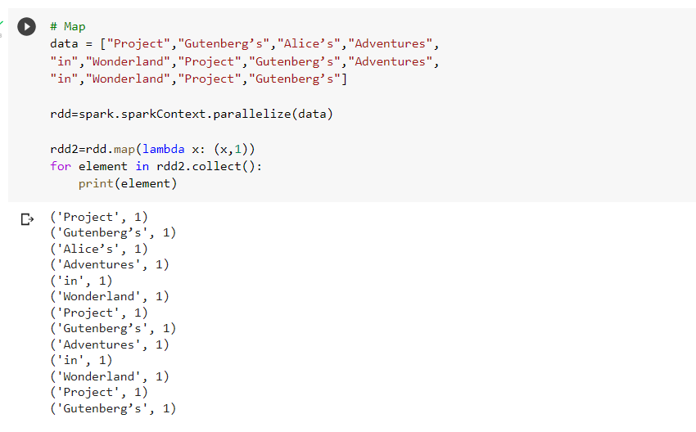

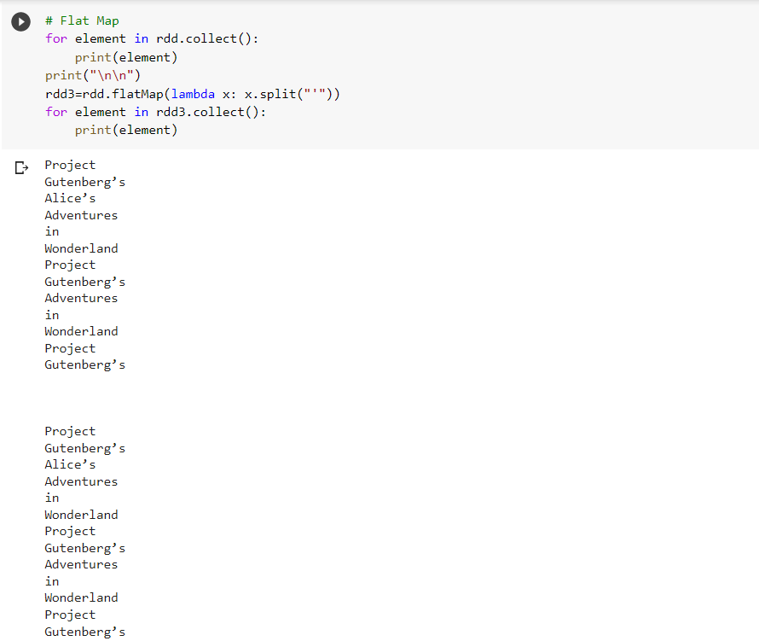

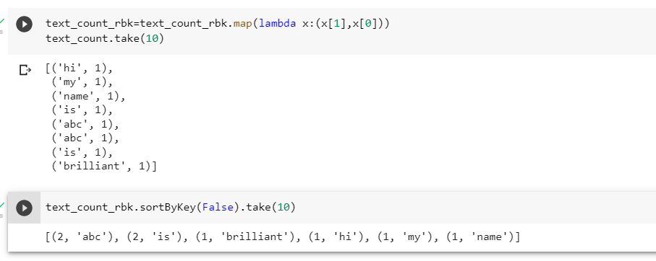

**Part B: Word Count using RDD in spark**

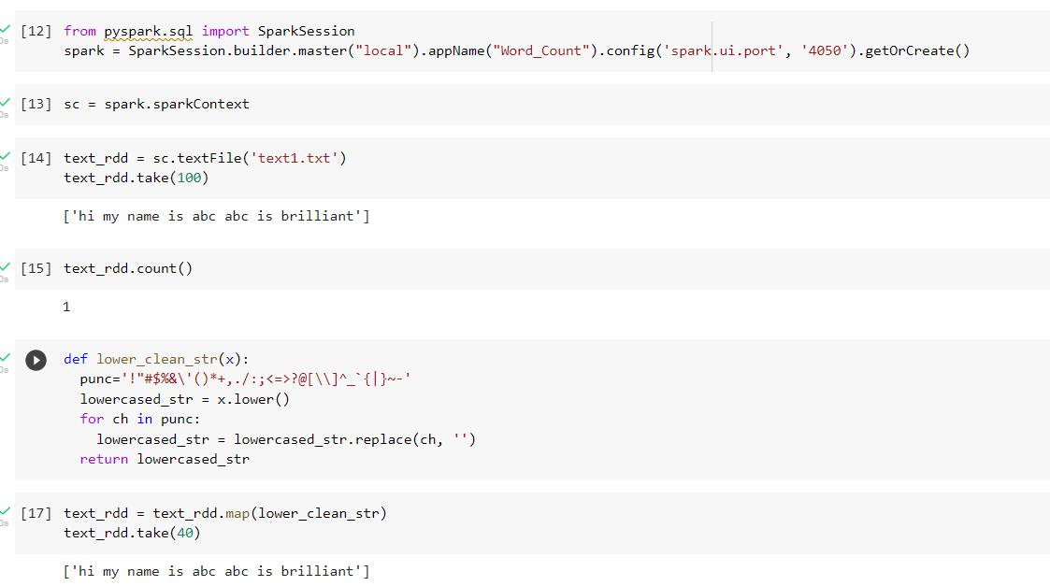

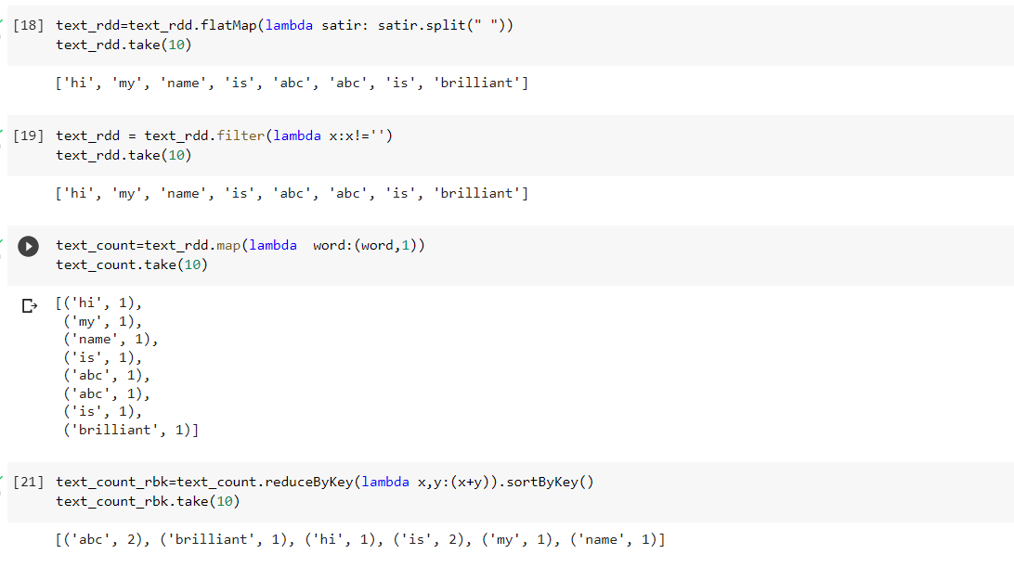



**CONCLUSION:**

Thus, in this way created RDDS and also implemented word count in spark

EXPERIMENT - 8

**AIM:** Execute any two ML Algorithms using Apache Spark MLlib and compare the results.

**THEORY:**

**Spark MLlib:**

Spark MLlib is Apache Spark’s Machine Learning component. MLlib consists of popular algorithms and utilities. MLlib in Spark is a scalable Machine learning library that discusses both high-quality algorithm and high speed. The machine learning algorithms like regression, classification, clustering, pattern mining, and collaborative filtering. Lower level machine learning primitives like generic gradient descent optimization algorithm are also present in MLlib.

spark.mllib contains the original API built on top of RDDs. It is currently in maintenance mode.

spark.ml provides higher level API built on top of DataFrames for constructing ML pipelines. spark.ml is the primary Machine Learning API for Spark at the moment.

**Spark MLlib Tools :**

* **ML Algorithms:** ML Algorithms form the core of MLlib. These include common learning algorithms such as classification, regression, clustering and collaborative filtering.
* **Featurization:** Featurization includes feature extraction, transformation, dimensionality reduction and selection.
* **Pipelines:** Pipelines provide tools for constructing, evaluating and tuning ML Pipelines.
* **Persistence:** Persistence helps in saving and loading algorithms, models and Pipelines.
* **Utilities:** Utilities for linear algebra, statistics and data handling.



**MLlib Algorithms:**

The popular algorithms and utilities in Spark MLlib are:

* Basic Statistics
* Regression
* Classification
* Recommendation System
* Clustering
* Dimensionality Reduction
* Feature Extraction
* Optimization

**CODE:**

| !apt-get install openjdk-8-jdk-headless -qq |
| --- |

| !apt-get·install·openjdk-8-jdk-headless·-qq |
| --- |

| Selecting previously unselected package openjdk-8-jre-headless:amd64. (Reading database ... 155632 files and directories currently installed.) Preparing to unpack .../openjdk-8-jre-headless_8u312-b07-0ubuntu1~18.04_amd64.deb ... Unpacking openjdk-8-jre-headless:amd64 (8u312-b07-0ubuntu1~18.04) ... Selecting previously unselected package openjdk-8-jdk-headless:amd64. Preparing to unpack .../openjdk-8-jdk-headless_8u312-b07-0ubuntu1~18.04_amd64.deb ... Unpacking openjdk-8-jdk-headless:amd64 (8u312-b07-0ubuntu1~18.04) ... Setting up openjdk-8-jre-headless:amd64 (8u312-b07-0ubuntu1~18.04) ... update-alternatives: using /usr/lib/jvm/java-8-openjdk-amd64/jre/bin/orbd to provide /usr/bin/orbd (orbd) in auto mode update-alternatives: using /usr/lib/jvm/java-8-openjdk-amd64/jre/bin/servertool to provide /usr/bin/servertool (servertool) in auto mode update-alternatives: using /usr/lib/jvm/java-8-openjdk-amd64/jre/bin/tnameserv to provide /usr/bin/tnameserv (tnameserv) in auto mode Setting up openjdk-8-jdk-headless:amd64 (8u312-b07-0ubuntu1~18.04) ... update-alternatives: using /usr/lib/jvm/java-8-openjdk-amd64/bin/idlj to provide /usr/bin/idlj (idlj) in auto mode update-alternatives: using /usr/lib/jvm/java-8-openjdk-amd64/bin/wsimport to provide /usr/bin/wsimport (wsimport) in auto mode update-alternatives: using /usr/lib/jvm/java-8-openjdk-amd64/bin/jsadebugd to provide /usr/bin/jsadebugd (jsadebugd) in auto mode update-alternatives: using /usr/lib/jvm/java-8-openjdk-amd64/bin/native2ascii to provide /usr/bin/native2ascii (native2ascii) in auto mode update-alternatives: using /usr/lib/jvm/java-8-openjdk-amd64/bin/javah to provide /usr/bin/javah (javah) in auto mode update-alternatives: using /usr/lib/jvm/java-8-openjdk-amd64/bin/hsdb to provide /usr/bin/hsdb (hsdb) in auto mode update-alternatives: using /usr/lib/jvm/java-8-openjdk-amd64/bin/clhsdb to provide /usr/bin/clhsdb (clhsdb) in auto mode update-alternatives: using /usr/lib/jvm/java-8-openjdk-amd64/bin/xjc to provide /usr/bin/xjc (xjc) in auto mode update-alternatives: using /usr/lib/jvm/java-8-openjdk-amd64/bin/schemagen to provide /usr/bin/schemagen (schemagen) in auto mode update-alternatives: using /usr/lib/jvm/java-8-openjdk-amd64/bin/extcheck to provide /usr/bin/extcheck (extcheck) in auto mode update-alternatives: using /usr/lib/jvm/java-8-openjdk-amd64/bin/jhat to provide /usr/bin/jhat (jhat) in auto mode update-alternatives: using /usr/lib/jvm/java-8-openjdk-amd64/bin/wsgen to provide /usr/bin/wsgen (wsgen) in auto mode |
| --- |

| !wget -q https://archive.apache.org/dist/spark/spark-3.0.0/spark-3.0.0-bin-hadoop3.2.tgz |
| --- |

| !tar xf spark-3.0.0-bin-hadoop3.2.tgz |
| --- |

| !pip install -q findspark |
| --- |

| import os os.environ["JAVA_HOME"] = "/usr/lib/jvm/java-8-openjdk-amd64" os.environ["SPARK_HOME"] = "/content/spark-3.0.0-bin-hadoop3.2"  import findspark findspark.init()  findspark.find() |
| --- |

| **/content/spark-3.0.0-bin-hadoop3.2** |
| --- |

| from pyspark.sql import SparkSession  spark = SparkSession.builder\  .master("local")\  .appName("Colab")\  .config('spark.ui.port', '4050')\  .getOrCreate()  spark |
| --- |

| **SparkSession - in-memory  SparkContext  Spark UI  Version v3.0.0 Master local AppName Colab** |
| --- |

| **!wget https://bin.equinox.io/c/4VmDzA7iaHb/ngrok-stable-linux-amd64.zip !unzip ngrok-stable-linux-amd64.zip** |
| --- |

| **--2022-06-15 14:23:32-- https://bin.equinox.io/c/4VmDzA7iaHb/ngrok-stable-linux-amd64.zip Resolving bin.equinox.io (bin.equinox.io)... 54.161.241.46, 18.205.222.128, 54.237.133.81, ... Connecting to bin.equinox.io (bin.equinox.io)|54.161.241.46|:443... connected. HTTP request sent, awaiting response... 200 OK Length: 13832437 (13M) [application/octet-stream] Saving to: 'ngrok-stable-linux-amd64.zip'  ngrok-stable-linux- 100%[===================>] 13.19M 51.8MB/s in 0.3s   2022-06-15 14:23:32 (51.8 MB/s) - 'ngrok-stable-linux-amd64.zip' saved [13832437/13832437]  Archive: ngrok-stable-linux-amd64.zip  inflating: ngrok** |
| --- |

| **get_ipython().system_raw('./ngrok http 4050 &') !curl -s http://localhost:4040/api/tunnels** |
| --- |

| **{"tunnels":[],"uri":"/api/tunnels"}** |
| --- |

| **!/content/ngrok authtoken 28vGHKeB8z7Z5fpbJUql9gT8jl5_Qm96Hsui43Um6XjhYq3o** |
| --- |

| **Authtoken saved to configuration file: /root/.ngrok2/ngrok.yml** |
| --- |

| **!ls -la** |
| --- |

| **!wget https://bin.equinox.io/c/4VmDzA7iaHb/ngrok-stable-linux-amd64.zip !unzip ngrok-stable-linux-amd64.zip** |
| --- |

| **--2022-06-15 14:23:32-- https://bin.equinox.io/c/4VmDzA7iaHb/ngrok-stable-linux-amd64.zip Resolving bin.equinox.io (bin.equinox.io)... 54.161.241.46, 18.205.222.128, 54.237.133.81, ... Connecting to bin.equinox.io (bin.equinox.io)|54.161.241.46|:443... connected. HTTP request sent, awaiting response... 200 OK Length: 13832437 (13M) [application/octet-stream] Saving to: 'ngrok-stable-linux-amd64.zip'  ngrok-stable-linux- 100%[===================>] 13.19M 51.8MB/s in 0.3s   2022-06-15 14:23:32 (51.8 MB/s) - 'ngrok-stable-linux-amd64.zip' saved [13832437/13832437]  Archive: ngrok-stable-linux-amd64.zip  inflating: ngrok** |
| --- |

| **get_ipython().system_raw('./ngrok·http·4050·&') !curl·-s·http://localhost:4040/api/tunnels** |
| --- |

| **{"tunnels":[],"uri":"/api/tunnels"}** |
| --- |

| **!/content/ngrok·authtoken·28vGHKeB8z7Z5fpbJUql9gT8jl5_Qm96Hsui43Um6XjhYq3o** |
| --- |

| **Authtoken saved to configuration file: /root/.ngrok2/ngrok.yml** |
| --- |

| **!ls·-la·** |
| --- |

| **total 262080 drwxr-xr-x 1 root root 4096 Jun 15 14:23 . drwxr-xr-x 1 root root 4096 Jun 15 14:20 .. drwxr-xr-x 4 root root 4096 Jun 1 13:49 .config -rwxr-xr-x 1 root root 30053267 May 4 2021 ngrok -rw-r--r-- 1 root root 13832437 Jun 15 14:23 ngrok-stable-linux-amd64.zip drwxr-xr-x 1 root root 4096 Jun 1 13:50 sample_data drwxr-xr-x 13 1000 1000 4096 Jun 6 2020 spark-3.0.0-bin-hadoop3.2 -rw-r--r-- 1 root root 224453229 Jun 6 2020 spark-3.0.0-bin-hadoop3.2.tgz** |
| --- |

| **!wget https://archive.ics.uci.edu/ml/machine-learning-databases/iris/iris.data** |
| --- |

| **--2022-06-15 14:23:33-- https://archive.ics.uci.edu/ml/machine-learning-databases/iris/iris.data Resolving archive.ics.uci.edu (archive.ics.uci.edu)... 128.195.10.252 Connecting to archive.ics.uci.edu (archive.ics.uci.edu)|128.195.10.252|:443... connected. HTTP request sent, awaiting response... 200 OK Length: 4551 (4.4K) [application/x-httpd-php] Saving to: 'iris.data'  iris.data 100%[===================>] 4.44K --.-KB/s in 0s   2022-06-15 14:23:34 (61.3 MB/s) - 'iris.data' saved [4551/4551]** |
| --- |

| **!wget https://archive.ics.uci.edu/ml/machine-learning-databases/iris/iris.names** |
| --- |

EDA:

| !cat dataset/iris.names |
| --- |

| cat: dataset/iris.names: No such file or directory |
| --- |

| import pandas as pd import seaborn as sns from sklearn import preprocessing |
| --- |

| df = pd.read_csv('iris.data', header=None, names=["D1", "D2", "D3", "D4", "Class"])  le = preprocessing.LabelEncoder() le.fit(df.iloc[:,4]) |
| --- |

| LabelEncoder() |
| --- |

| df['Class'] = le.transform(df['Class']) df |
| --- |

| **D1** | **D2** | **D3** | **D4** | **Class** |  |
| --- | --- | --- | --- | --- | --- |
| **0** | 5.1 | 3.5 | 1.4 | 0.2 | 0 |
| **1** | 4.9 | 3.0 | 1.4 | 0.2 | 0 |
| **2** | 4.7 | 3.2 | 1.3 | 0.2 | 0 |
| **3** | 4.6 | 3.1 | 1.5 | 0.2 | 0 |
| **4** | 5.0 | 3.6 | 1.4 | 0.2 | 0 |
| **...** | ... | ... | ... | ... | ... |
| **145** | 6.7 | 3.0 | 5.2 | 2.3 | 2 |
| **146** | 6.3 | 2.5 | 5.0 | 1.9 | 2 |
| **147** | 6.5 | 3.0 | 5.2 | 2.0 | 2 |
| **148** | 6.2 | 3.4 | 5.4 | 2.3 | 2 |
| **149** | 5.9 | 3.0 | 5.1 | 1.8 | 2 |

150 rows × 5 columns

| **df[:,].to_csv('iris-encoded.csv', header=None) sns.pairplot(df, hue='Class')** |
| --- |

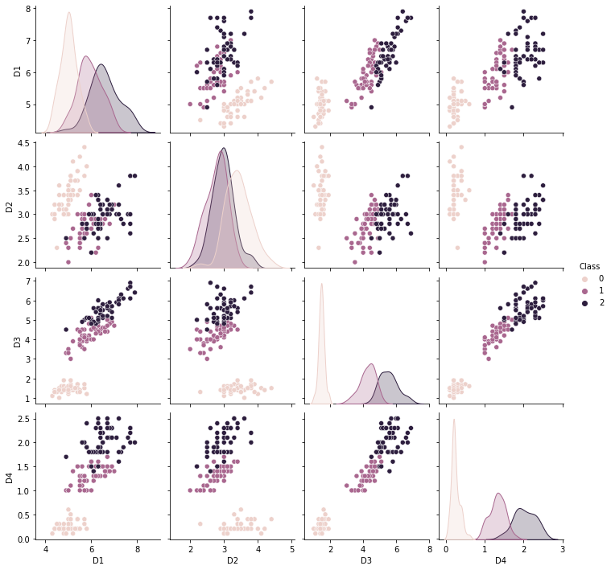

| **!sudo apt-get install libgfortran3** |
| --- |

| Reading package lists... Done Building dependency tree  Reading state information... Done The following package was automatically installed and is no longer required:  libnvidia-common-460 Use 'sudo apt autoremove' to remove it. The following additional packages will be installed:  gcc-6-base The following NEW packages will be installed:  gcc-6-base libgfortran3 0 upgraded, 2 newly installed, 0 to remove and 45 not upgraded. Need to get 286 kB of archives. After this operation, 1,394 kB of additional disk space will be used. Get:1 http://archive.ubuntu.com/ubuntu bionic-updates/universe amd64 gcc-6-base amd64 6.5.0-2ubuntu1~18.04 [16.7 kB] Get:2 http://archive.ubuntu.com/ubuntu bionic-updates/universe amd64 libgfortran3 amd64 6.5.0-2ubuntu1~18.04 [270 kB] Fetched 286 kB in 1s (290 kB/s) debconf: unable to initialize frontend: Dialog debconf: (No usable dialog-like program is installed, so the dialog based frontend cannot be used. at /usr/share/perl5/Debconf/FrontEnd/Dialog.pm line 76, <> line 2.) debconf: falling back to frontend: Readline debconf: unable to initialize frontend: Readline debconf: (This frontend requires a controlling tty.) debconf: falling back to frontend: Teletype dpkg-preconfigure: unable to re-open stdin:  Selecting previously unselected package gcc-6-base:amd64. (Reading database ... 155975 files and directories currently installed.) Preparing to unpack .../gcc-6-base_6.5.0-2ubuntu1~18.04_amd64.deb ... Unpacking gcc-6-base:amd64 (6.5.0-2ubuntu1~18.04) ... Selecting previously unselected package libgfortran3:amd64. Preparing to unpack .../libgfortran3_6.5.0-2ubuntu1~18.04_amd64.deb ... Unpacking libgfortran3:amd64 (6.5.0-2ubuntu1~18.04) ... Setting up gcc-6-base:amd64 (6.5.0-2ubuntu1~18.04) ... Setting up libgfortran3:amd64 (6.5.0-2ubuntu1~18.04) ... Processing triggers for libc-bin (2.27-3ubuntu1.3) ... /sbin/ldconfig.real: /usr/local/lib/python3.7/dist-packages/ideep4py/lib/libmkldnn.so.0 is not a symbolic link |
| --- |

| **sc = spark.sparkContext  from pyspark.mllib.clustering import KMeans, GaussianMixture from numpy import array from math import sqrt  # Load and parse the data data = sc.textFile("iris-encoded.csv") parsedData = data.map(lambda line: array([float(x) for x in line.split(',') if x]))** |
| --- |

| **clusters = KMeans.train(parsedData, 2, maxIterations=10)  def error(point):  center = clusters.centers[clusters.predict(point)]  return sqrt(sum([x**2 for x in (point - center)]))  WSSSE = parsedData.map(lambda point: error(point)).reduce(lambda x, y: x + y) print("KMeans: Sum of Squared Error = " + str(WSSSE))** |
| --- |

| **KMeans: Sum of Squared Error = 2828.724531888541** |
| --- |

| **clusters2 = GaussianMixture.train(parsedData, 1, maxIterations=10)  def error2(point):  center = clusters2.predict(point)  return sqrt(sum([x**2 for x in (point - center)]))  WSSSE = parsedData.map(lambda point: error2(point)).reduce(lambda x, y: x + y) print("Gaussian Mixture: Sum of Squared Error = " + str(WSSSE))** |
| --- |

| **Gaussian Mixture: Sum of Squared Error = 3165.92681973472** |
| --- |

**CONCLUSION:** We successfully trained two Machine Learning models, one using KMeans algorithm and the other using Gaussian Mixture algorithm and KMeans had a lower Sum of Squared error therefore it is the better of the two algorithms.

EXPERIMENT - 9

**AIM:** To perform CRUD operations using MongoDB

**Theory**

MongoDB, the most popular NoSQL database, is an open-source document-oriented database. The term ‘NoSQL’ means ‘non-relational’. It means that MongoDB isn’t based on the table-like relational database structure but provides an altogether different mechanism for storage and retrieval of data. This format of storage is called BSON ( similar to JSON format). A simple MongoDB document Structure:

| { |
| --- |
| "_id": "10006546", |
| "listing_url": "https://www.airbnb.com/rooms/10006546", |
| "name": "Ribeira Charming Duplex", |
| "summary": "Fantastic duplex apartment with three bedrooms, located in the historic area of Porto, Ribeira (Cube)...", |
| "interaction": "Cot - 10 € / night Dog - € 7,5 / night", |
| "house_rules": "Make the house your home...", |
| "property_type": "House", |
| "room_type": "Entire home/apt", |
| "bed_type": "Real Bed", |
| "minimum_nights": "2", |
| } |

SQL databases store data in tabular format. This data is stored in a predefined data model which is not very much flexible for today’s real-world highly growing applications. Modern applications are more networked, social and interactive than ever. Applications are storing more and more data and are accessing it at higher rates. Relational Database Management System(RDBMS) is not the correct choice when it comes to handling big data by the virtue of their design since they are not horizontally scalable. If the database runs on a single server, then it will reach a scaling limit. NoSQL databases are more scalable and provide superior performance. MongoDB is such a NoSQL database that scales by adding more and more servers and increases productivity with its flexible document model.

**RDBMS vs MongoDB**

RDBMS has a typical schema design that shows number of tables and the relationship between these tables whereas MongoDB is document-oriented. There is no concept of schema or relationship.

Complex transactions are not supported in MongoDB because complex join operations are not available.

MongoDB allows a highly flexible and scalable document structure. For example, one data document of a collection in MongoDB can have two fields whereas the other document in the same collection can have four.

MongoDB is faster as compared to RDBMS due to efficient indexing and storage techniques.

There are a few terms that are related in both databases. What’s called Table in RDBMS is called a Collection in MongoDB. Similarly, a Tuple is called a Document and A Column is called a Field. MongoDB provides a default ‘_id’ (if not provided explicitly) which is a 12-byte hexadecimal number that assures the uniqueness of every document. It is similar to the Primary key in RDBMS.

**Features of MongoDB**

* Document Oriented: MongoDB stores the main subject in the minimal number of documents and not by breaking it up into multiple relational structures like RDBMS. For example, it stores all the information of a computer in a single document called Computer and not in distinct relational structures like CPU, RAM, Hard disk, etc.
* Indexing: Without indexing, a database would have to scan every document of a collection to select those that match the query which would be inefficient. So, for efficient searching Indexing is a must and MongoDB uses it to process huge volumes of data in very less time.
* Scalability: MongoDB scales horizontally using sharding (partitioning data across various servers). Data is partitioned into data chunks using the shard key, and these data chunks are evenly distributed across shards that reside across many physical servers. Also, new machines can be added to a running database.
* Replication and High Availability: MongoDB increases the data availability with multiple copies of data on different servers. By providing redundancy, it protects the database from hardware failures. If one server goes down, the data can be retrieved easily from other active servers which also had the data stored on them.
* Aggregation: Aggregation operations process data records and return the computed results. It is similar to the GROUPBY clause in SQL. A few aggregation expressions are sum, avg, min, max, etc

Where do we use MongoDB?

* Big Data: If you have huge amount of data to be stored in tables, think of MongoDB before RDBMS databases. MongoDB has built-in solution for partitioning and sharding your database.
* Unstable Schema: Adding a new column in RDBMS is hard whereas MongoDB is schema-less. Adding a new field does not affect old documents and will be very easy.
* Distributed data Since multiple copies of data are stored across different servers, recovery of data is instant and safe even if there is a hardware failure.

**Implementation**

| test> show dbs |
| --- |
| use books; db.createCollection("authors") db.createCollection("books") show collections |

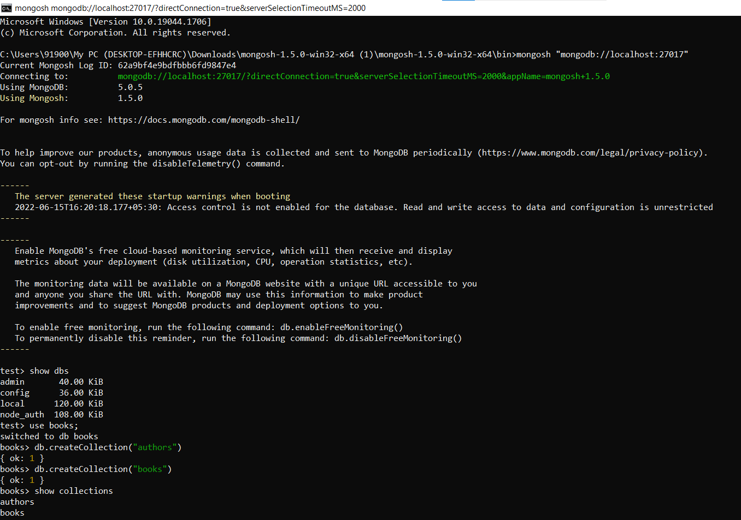

Create (C)

| books> db.books.insertMany([ ... {"name": "How to win friends and influence people", "author": "Dale Carnegie"}, ... {"name": "Elephants can remember", "author": "Agatha Christie"}, ... {"name": "Plague ship", "author": "Clive Cussler"} ... ]) books> db.books.insert({"name": "The hooded hawk mystery", "author": "Franklin W. Dixon"}) books> db.books.insertOne({"name": "The shore road mystery", "author": "Franklin W. Dixon"}) |
| --- |

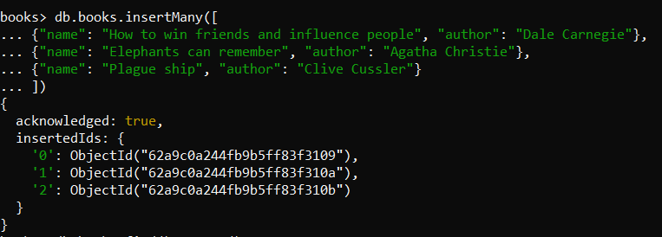

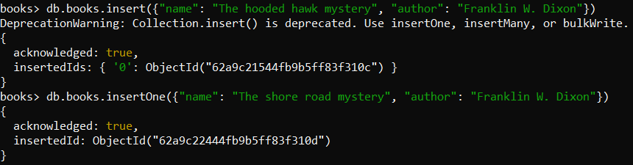

Read (R)

| books> db.books.find().pretty() books> db.books.find({"author": "Dale Carnegie"}) |
| --- |

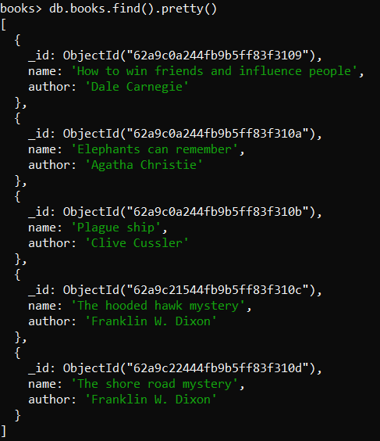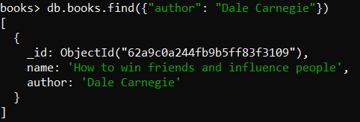

Update (U)

| books> db.books.update({"author": "Clive Cussler"}, {$set: {"name": "Black Wind"}}) books> db.books.find({"author": "Clive Cussler"}) books> db.books.updateOne({"author": "Agatha Christie"}, {$set: {"name": "They came to Baghdad"}}) books> db.books.find({"author": "Agatha Christie"}) books> db.books.updateMany({"author": "Franklin W. Dixon"}, {$set: {"author": "Carolyn Keene"}}) books> db.books.find({"author": "Carolyn Keene"}) |
| --- |

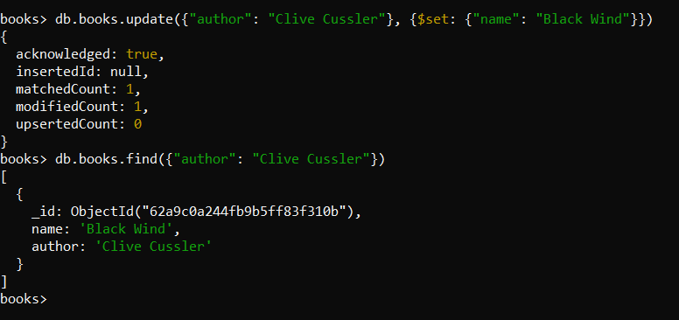

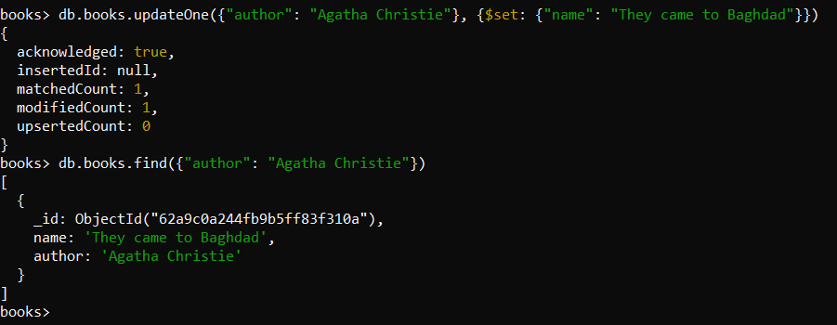

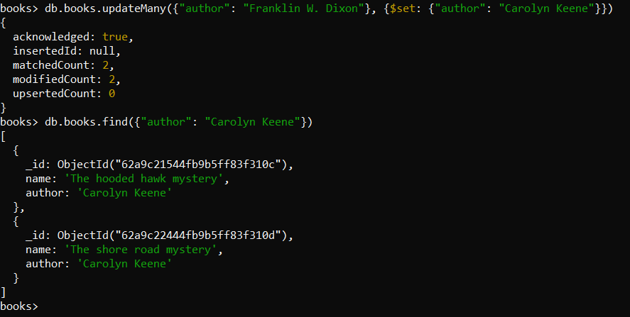

Delete (D)

| books> db.books.deleteOne({"author": "Agatha Christie"}) books> db.books.find().pretty() books> db.books.deleteMany({"author": "Carolyn Keene"}) books> db.books.find().pretty() |
| --- |

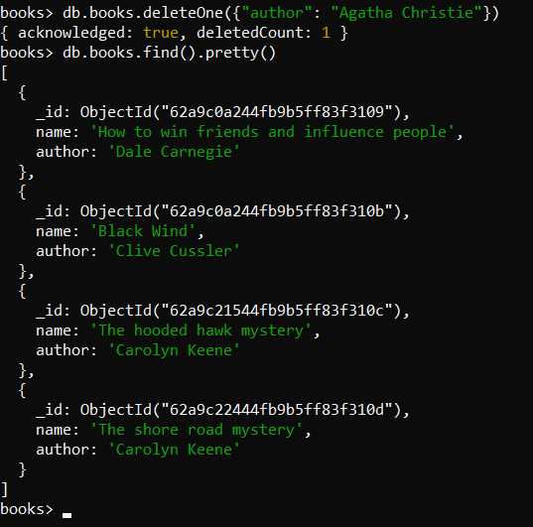 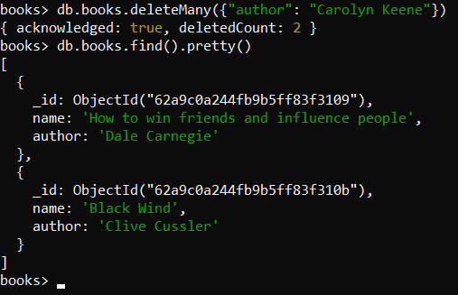

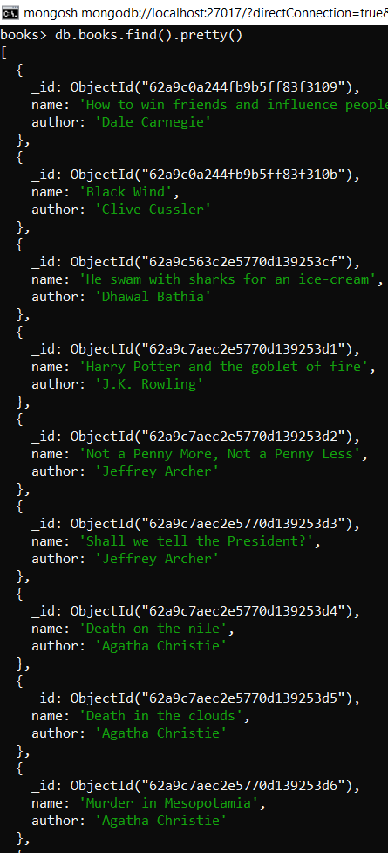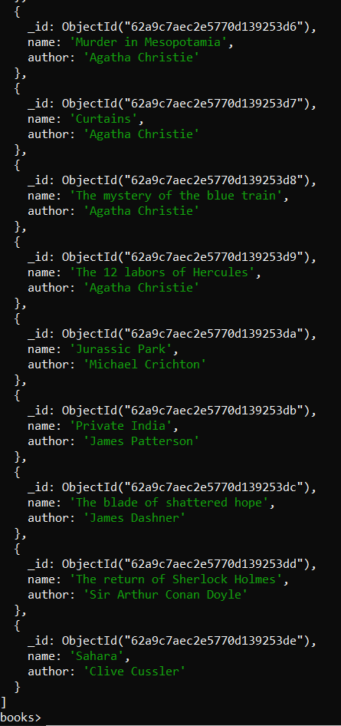

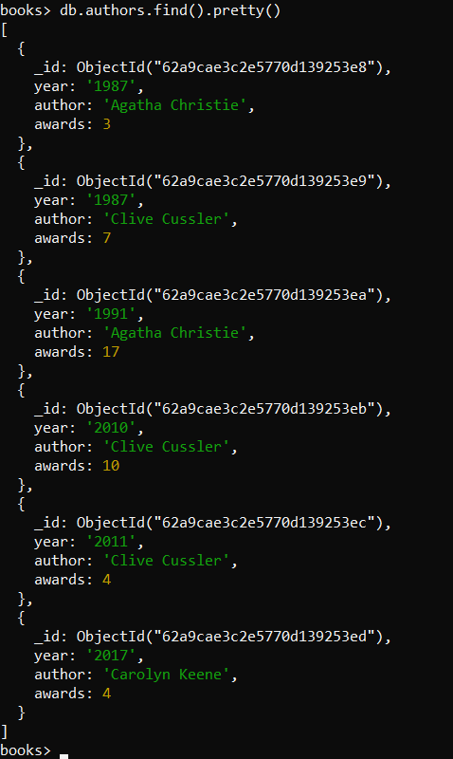

Aggregate Queries

| books> db.authors.aggregate([ { $group: { _id: "$author", totalawards: { $sum: "$awards" } } }]); books> db.books.find().pretty() |
| --- |

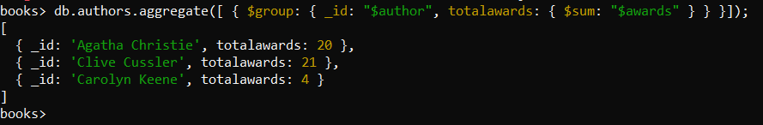

| books> db.authors.aggregate([ ... { ..... $lookup:{from:"books", localField: "author", foreignField: "author", as: "output_array_field"} ..... }]) |
| --- |

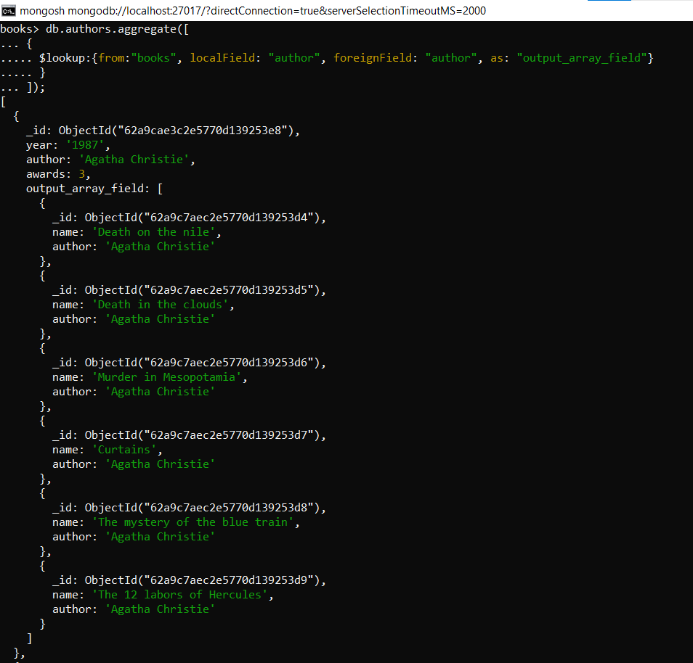

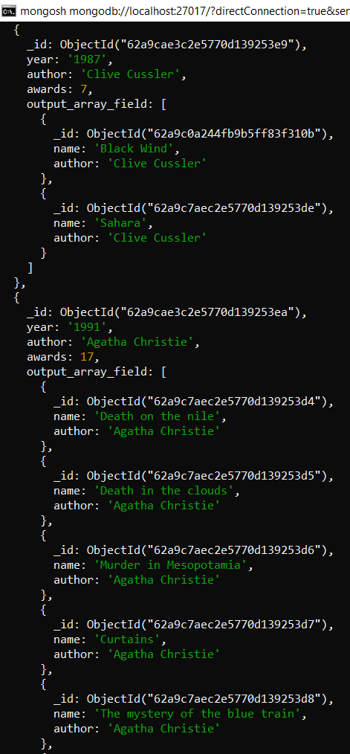 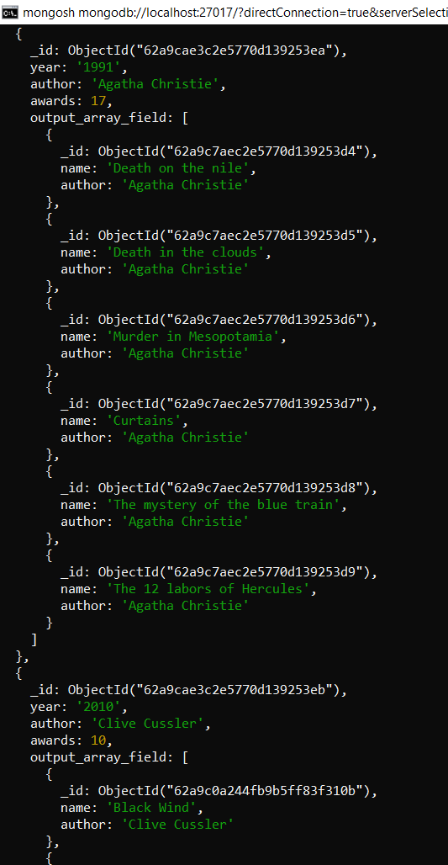

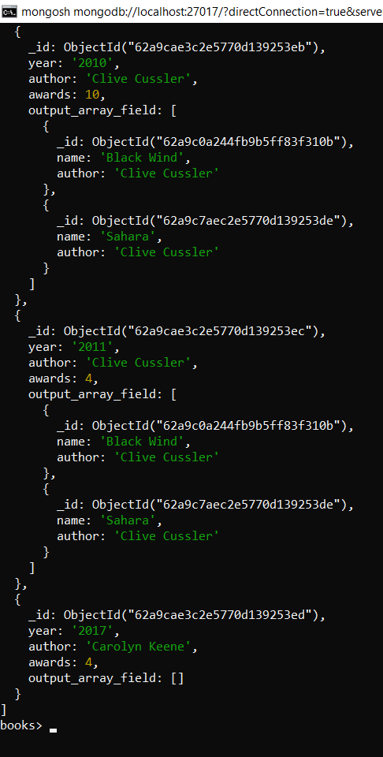

**Conclusion**

In this experiment, we implemented CRUD operations in MongoDB using the Mongosh shell. We also implemented the aggregate queries to perform the “sum” operation and some sort of a join with a foreign key between two collections.

EXPERIMENT - 10

**Aim:** Read streaming data using Kafka.

**Theory:**

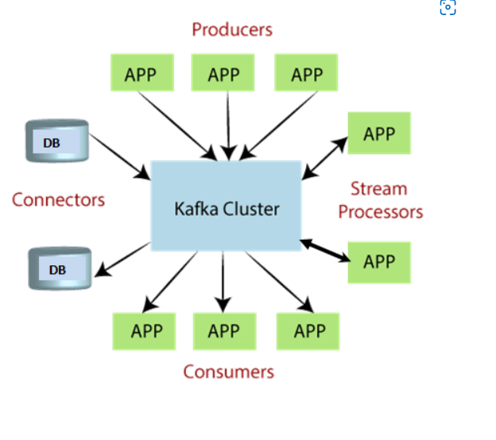

**What is Apache Kafka?**

Apache Kafka is a software platform which is based on a distributed streaming process. It is a publish-subscribe messaging system which let exchanging of data between applications, servers, and processors as well. Apache Kafka was originally developed by LinkedIn, and later it was donated to the Apache Software Foundation. Currently, it is maintained by Confluent under Apache Software Foundation. Apache Kafka has resolved the lethargic trouble of data communication between a sender and a receiver.

**What is a messaging system?**

A messaging system is a simple exchange of messages between two or more persons, devices, etc. A publish-subscribe messaging system allows a sender to send/write the message and a receiver to read that message. In Apache Kafka, a sender is known as a producer who publishes messages, and a receiver is known as a consumer who consumes that message by subscribing it.

**What is Streaming process?**

A streaming process is the processing of data in parallelly connected systems. This process allows different applications to limit the parallel execution of the data, where one record executes without waiting for the output of the previous record. Therefore, a distributed streaming platform enables the user to simplify the task of the streaming process and parallel execution. Therefore, a streaming platform in Kafka has the following key capabilities:

* As soon as the streams of records occur, it processes it.
* It works similar to an enterprise messaging system where it publishes and subscribes streams of records.
* It stores the streams of records in a fault-tolerant durable way.

To learn and understand Apache Kafka, the aspirants should know the following four core APIs:

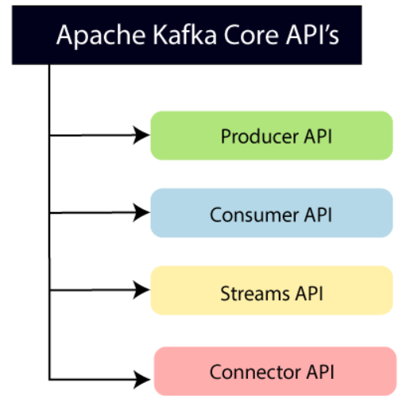

**Producer API:** This API allows/permits an application to publish streams of records to one or more topics. (discussed in later section)

**Consumer API:** This API allows an application to subscribe one or more topics and process the stream of records produced to them.

**Streams API:** This API allows an application to effectively transform the input streams to the output streams. It permits an application to act as a stream processor which consumes an input stream from one or more topics, and produce an output stream to one or more output topics.

**Connector API:** This API executes the reusable producer and consumer APIs with the existing data systems or applications.

Messages are published to topics by Kafka Producers. Those who subscribe to them, on the other hand, are called Kafka Consumers.

Communication to and from Apache Kafka from Producers and Consumers is through a language agnostic TCP protocol, which is high-performing and simple. It assumes the responsibility for facilitating communications involving servers and clients.

**Topics and Logs**

A topic is considered a key abstraction in Kafka. A topic can be considered a feed name or category where the messages will be published. Each topic is further subdivided into partitions. Partitions split data across different nodes by Kafka brokers. In each of the messages within the partition, there is an ID number assigned, which is technically known as the offset.

**Kafka Topic Partitions**

All of the messages published can be retained in the cluster, regardless if they have been consumed or not. For instance, if the configuration states that it will be available only for one week, then it can be retained within such period only. Once the period has lapsed, it will be automatically deleted, which, in turn, will provide the system with additional space.

On a per consumer basis, only the meta-data, which is also technically known as the offset, is going to be retained. The consumers will have complete control of this retention. It is often consumed linearly, but the user can often go back and reprocess, basically because he or she is in control.

Consumers of Kafka are lightweight, cheap, and they do not have a significant impact on the way the clusters will perform. This differs from more traditional message systems. Every consumer has the ability to maintain their own offset, and hence, their actions will not affect other consumers.

**Kafka Partitions**

Why partitions? Partitions are leveraged for two purposes. The first is to adjust the size of the topic to make it fit on a single node. The second purpose of partition is for parallelism or performance tuning. It makes it possible for one consumer to simultaneously browse messages in concurrent threads. This will be further discussed later on.

**Distribution**

Every partition is replicated for fault tolerance. In every partition, there is a single server, which is labeled as the “Leader”. The leader is responsible for the handling of the requests for read-write. There will also be “Followers”, which can be zero or more nodes in the Kafka cluster. They will be responsible for replicating the actions undertaken by the leader. In the case of the failure of the leader, one of the followers will immediately assume the leadership position. We’ll cover more on Kafka fault tolerance in later tutorials.

**So, Why Kafka? When?**

When compared to the conventional messaging system, one of the benefits of Kafka is that it has ordering guarantees. In the case of a traditional queue, messages are kept on the server based on the order at which they are kept. Then messages are pushed out based on the order of their storage and there is no specific timing requirement in their transmission. This means that their arrival to different consumers could be random. Hold the phone. Did you just write “could be random”? Think about that for 5 seconds. That may be fine in some use cases, but not others.

Kafka is often deployed as the foundational element in Streaming Architectures because it can facilitate loose coupling between various components in architectures such as databases, microservices, Hadoop, data warehouses, distributed files systems, search applications, etc.

**Guarantees**

In a Kafka messaging system, there are essentially three guarantees:

1. A message sent by a producer to a topic partition is appended to the Kafka log based on the order sent.

2. Consumers see messages in the order of their log storage.

3. For topics with replication factor N, Kafka will tolerate N-1 number of failures without losing the messages previously committed to the log.

**Code:**

| import findspark findspark.init('') import pyspark from pyspark import RDD from pyspark import SparkContext from pyspark.streaming import StreamingContext from pyspark.streaming.kafka import KafkaUtils  if name=="main":  sc = SparkContext(appName="PythonSparkStreamingKafka")  ssc = StreamingContext(sc,60)  #Creating Kafka direct stream  message= KafkaUtils.createDirectStream(ssc, ["testtopic"], {"metadata.broker.list":"|replace with your Kafka private address|:9092"})  words=message.map(lambda x:x[1].flatmap(lambda x:x.split(" ")))  wordcount=words.map(lambda x: (x,1).reduceByKey(lambda a,b:a+b))  wordcount.ppr int()  #Starting Spark context  ssc.start()  ssc.awaitTermination() |
| --- |

**Commands:**

Open 4 command line terminals

On first terminal enter the command:

| **zookeeper-server-start.bat .\config\zookeeper.properties** |
| --- |

**Output:**

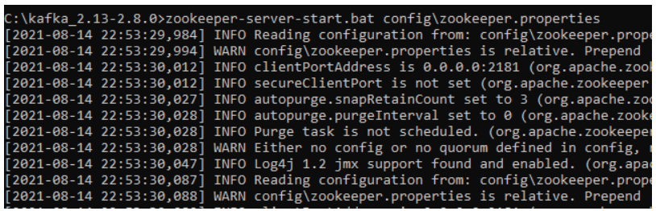

Zookeeper is up and running at the specified port.

On second terminal enter the command:

| **kafka-server-start.bat .\config\server.properties** |
| --- |

**Output:**

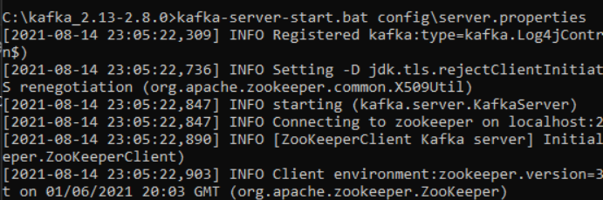

Now, you have the kafka running in one command line window and zookeeper running in another. If you want to start working with them, you will have to open another command line window and start writing commands.

On third terminal we run the command

| **kafka-console-producer.bat --broker-list localhost:9092 --topic testtopic** |
| --- |



On fourth terminal we run the command:

| **spark-submit --packages org.apache.spark:spark-streaming-kafka-0-8_2.11:2.1.1** |
| --- |

kafkademo is the python file which contains the code.

**Output:**



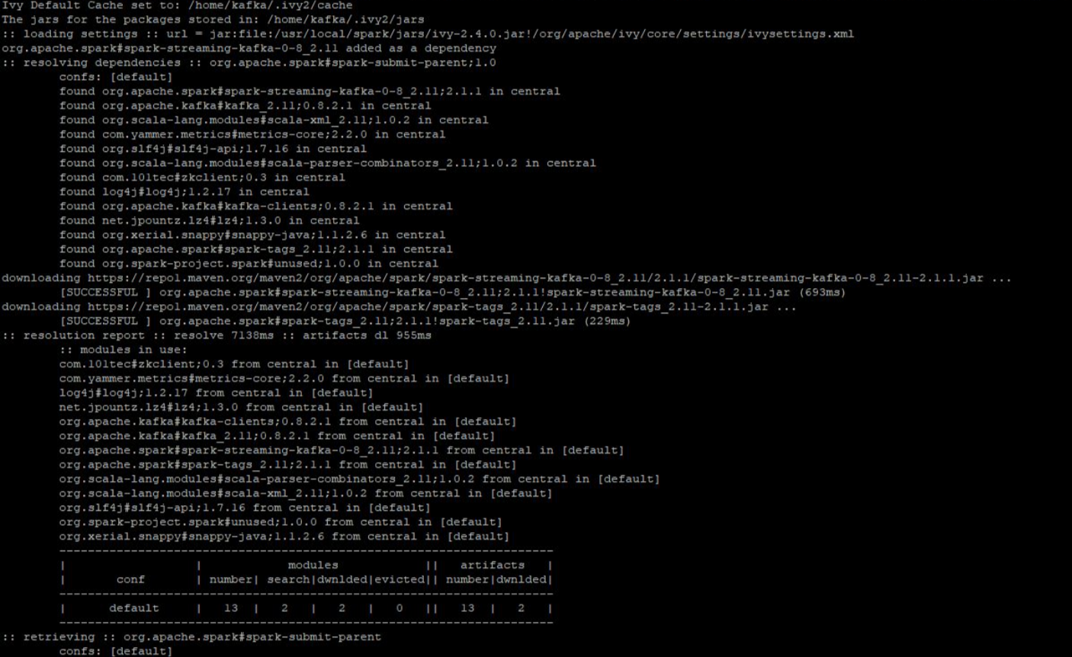

Now our command line is waiting for the data we enter the data in terminal 3:



And the output is obtained at terminal 4:

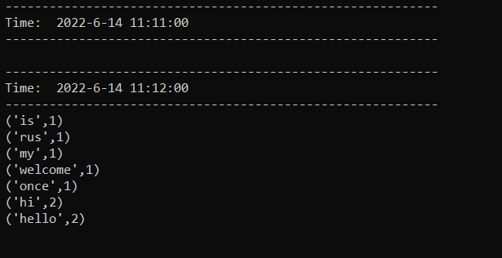

Conclusion: Thus we have successfully integrated kafka and spark and read streaming data using Kafka.

.

EXPERIMENT - 11

**Aim :** Case study to perform Sentiment analysis using Spark Streaming

**Theory**

**Spark Streaming**

Spark Streaming is an extension of the core Spark API that enables scalable, high-throughput, fault-tolerant stream processing of live data streams. Spark Streaming can be used to stream live data and processing can happen in real time. Spark Streaming’s ever-growing user base consists of household names like Uber, Netflix and Pinterest.

**Why Spark Streaming?**

We can use Spark Streaming to stream real-time data from various sources like Twitter, Stock Market and Geographical Systems and perform powerful analytics to help businesses. Spark Streaming is used for processing real-time streaming data. It is a useful addition to the core Spark API. Spark Streaming enables high-throughput and fault-tolerant stream processing of live data streams.

**Spark Streaming Features**

1. Scaling: Spark Streaming can easily scale to hundreds of nodes.
2. Speed: It achieves low latency.
3. Fault Tolerance: Spark has the ability to efficiently recover from failures.
4. Integration: Spark integrates with batch and real-time processing.
5. Business Analysis: Spark Streaming is used to track the behavior of customers which can be used in business analysis.

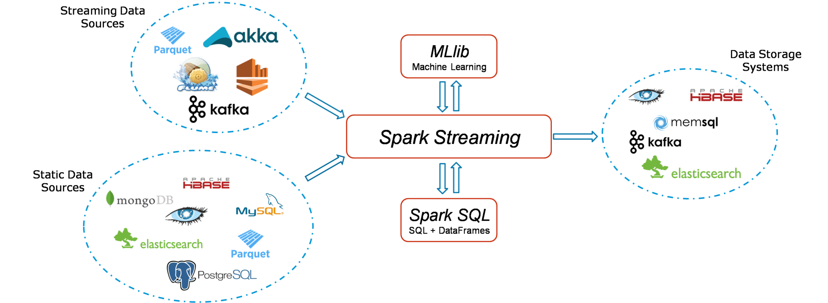

**Using Spark Streaming to perform Sentiment Analysis on Twitter Data**

To design a Twitter Sentiment Analysis System where we populate real-time sentiments for crisis management, service adjusting and target marketing.

**Applications of Sentiment Analysis**

1. Predict the success of a movie
2. Predict political campaign success
3. Decide whether to invest in a certain company
4. Targeted advertising
5. Review products and services

**Fundamentals Used**

1. Streaming Context

Streaming Context consumes a stream of data in Spark. It registers an Input DStream to produce a Receiver object. It is the main entry point for Spark functionality. Spark provides a number of default implementations of sources like Twitter, Akka Actor and ZeroMQ that are accessible from the context. A StreamingContext object can be created from a SparkContext object. A SparkContext represents the connection to a Spark cluster and can be used to create RDDs, accumulators and broadcast variables on that cluster.

1. DStream

Discretized Stream (DStream) is the basic abstraction provided by Spark Streaming. It is a continuous stream of data. It is received from a data source or a processed data stream generated by transforming the input stream. Internally, a DStream is represented by a continuous series of RDDs and each RDD contains data from a certain interval.

1. Input DStreams

Input DStreams are DStreams representing the stream of input data received from streaming sources. Every input DStream is associated with a Receiver object which receives the data from a source and stores it in Spark’s memory for processing.

1. Output DStreams

Output operations allow DStream’s data to be pushed out to external systems like databases or file systems. Output operations trigger the actual execution of all the DStream transformations.

1. Caching

DStreams allow developers to cache/ persist the stream’s data in memory. This is useful if the data in the DStream will be computed multiple times. This can be done using the persist() method on a DStream. For input streams that receive data over the network (such as Kafka, Flume, Sockets, etc.), the default persistence level is set to replicate the data to two nodes for fault-tolerance.

1. Accumulators

Accumulators are variables that are only added through an associative and commutative operation. They are used to implement counters or sums. Tracking accumulators in the UI can be useful for understanding the progress of running stages. Spark natively supports numeric accumulators. We can create named or unnamed accumulators.

1. Broadcast Variables

Broadcast variables allow the programmer to keep a read-only variable cached on each machine rather than shipping a copy of it with tasks. They can be used to give every node a copy of a large input dataset in an efficient manner. Spark also attempts to distribute broadcast variables using efficient broadcast algorithms to reduce communication cost.

1. Checkpoints

Checkpoints are similar to checkpoints in gaming. They make it run 24/7 and make it resilient to failures unrelated to the application logic.

**Results of Sentiment Analysis**

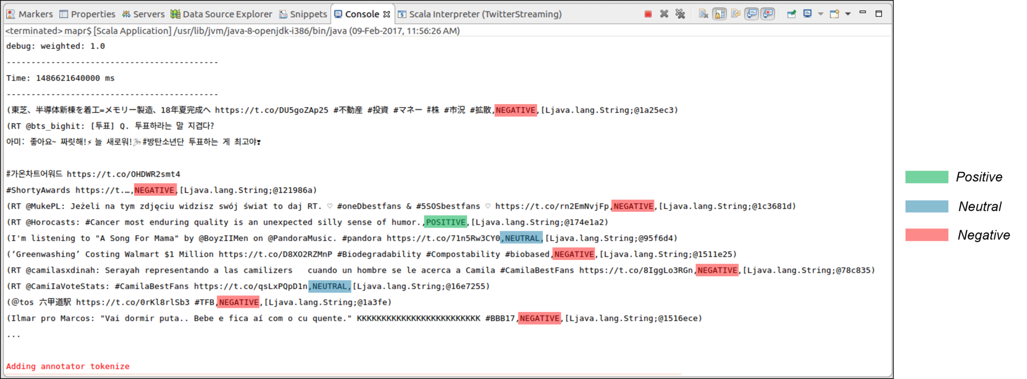

As we can see in the screenshot, all the tweets are categorized into Positive, Neutral and Negative according to the sentiment of the contents of the tweets. The output of the Sentiments of the Tweets is stored into folders and files according to the time they were created. This output can be stored on the local file system or HDFS as necessary. The output directory looks like this:

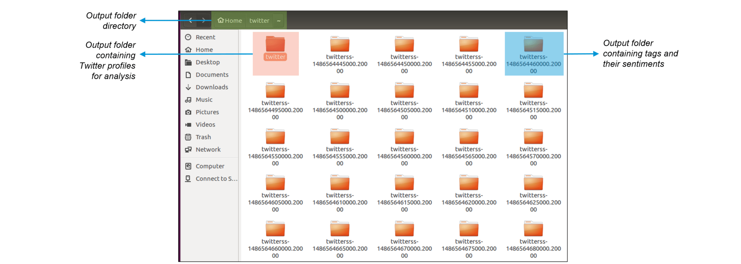

Here, inside the twitter directory, we can find the usernames of the Twitter users along with the timestamp for every tweet as shown below:

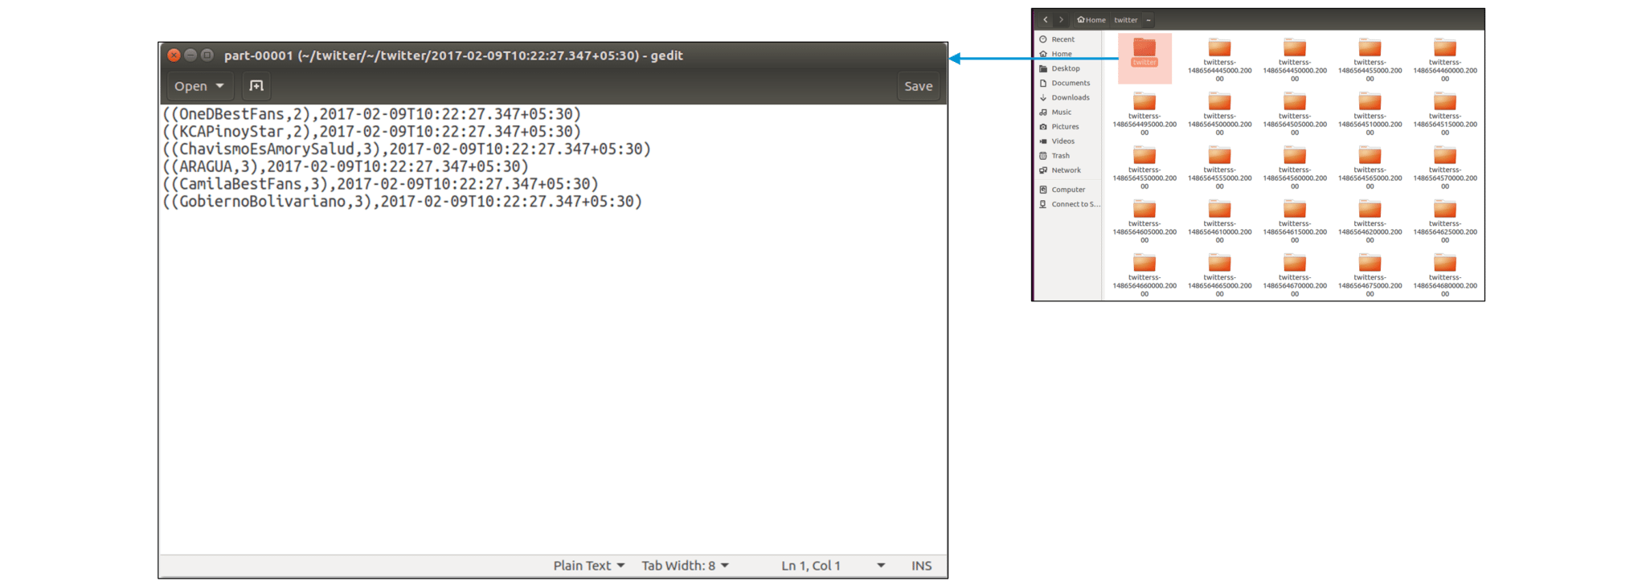

Now that we have got the Twitter usernames and timestamp, let us look at the Sentiments and tweets stored in the main directory. Here, every tweet is followed by the sentiment emotion. This Sentiment that is stored is further used for analysing a vast multitude of insights by companies.

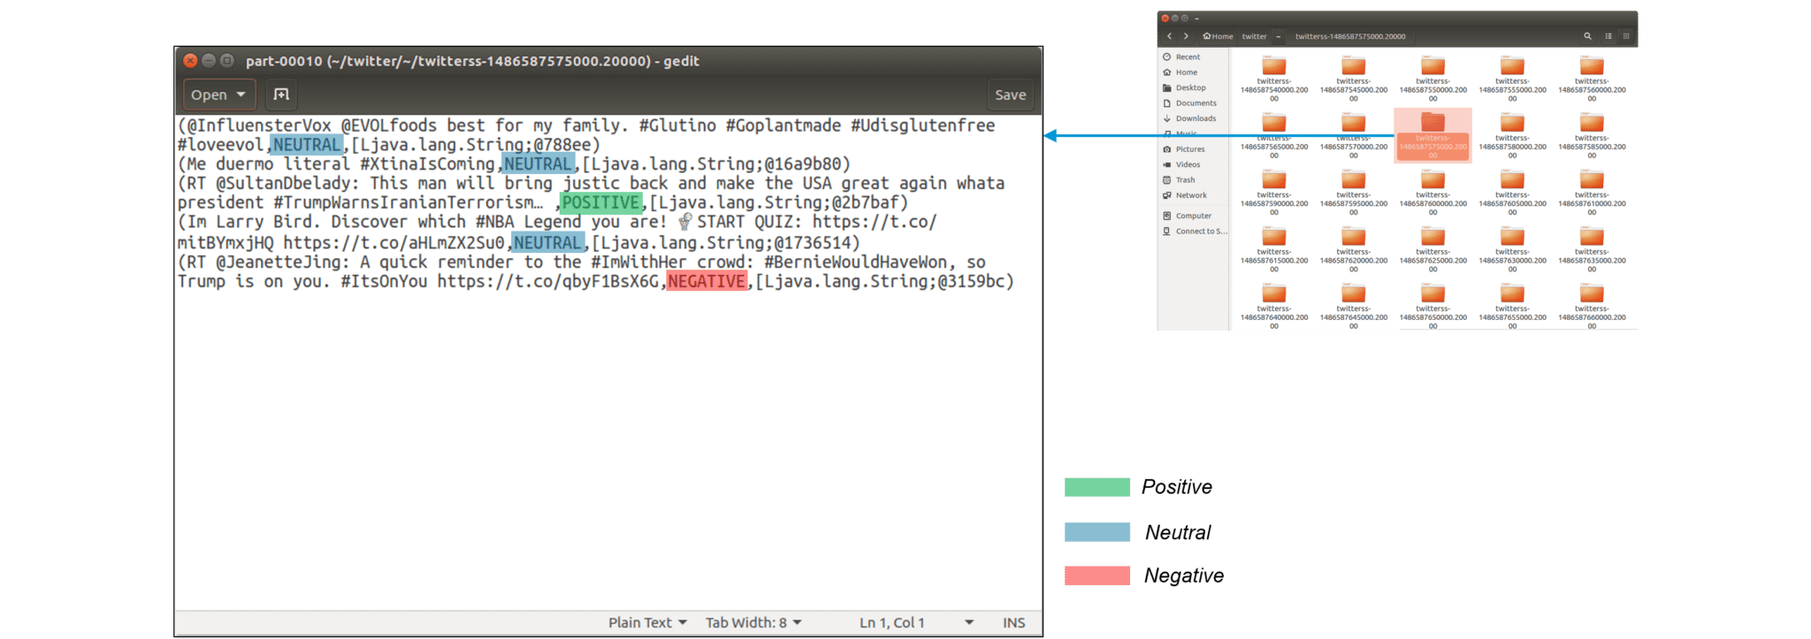

Now, let us modify our code a little to get sentiments for specific hashtags (topics). We look at the sentiments associated with the keyword ‘Trump‘.

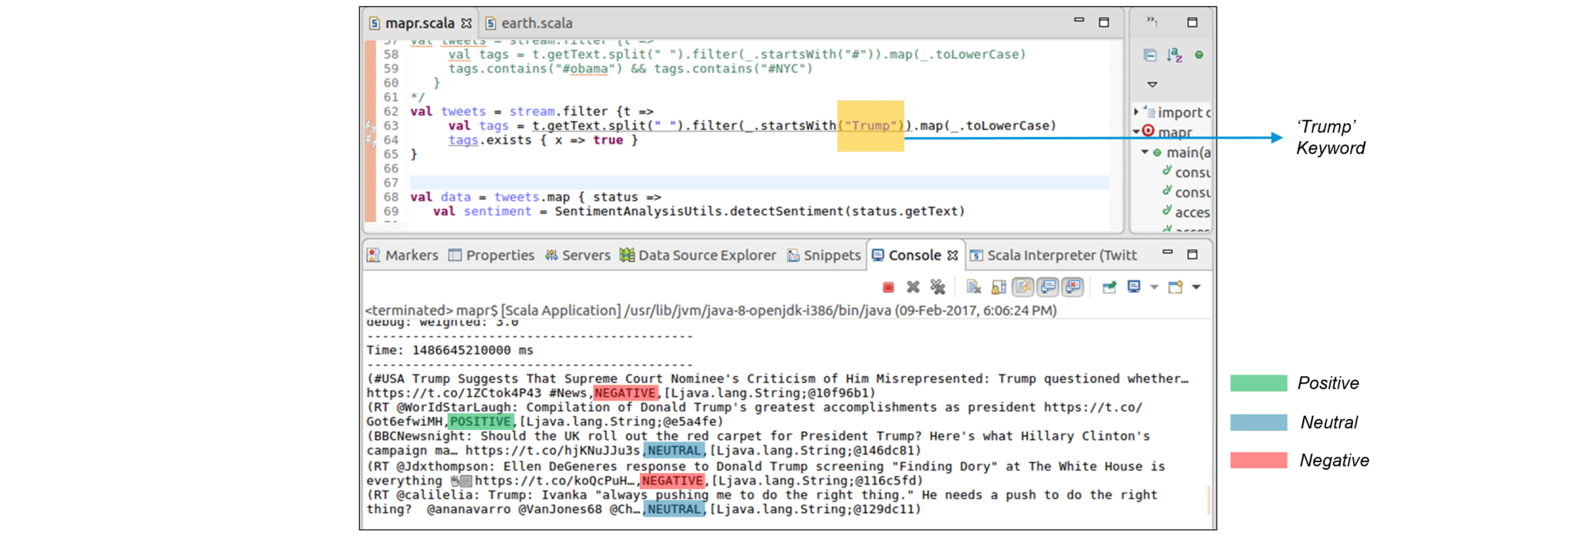

**Conclusion**

Spark Streaming is a part of Spark API that provides tolerant processing of live data streams. In this experiment we took live streams of data from the twitter API and used the live stream of data for performing Sentiment Analysis on the tweets received from the Twitter API. The Spark Stream used provides fast, scalable and fault tolerant processing of live data streams.